Zuoz Reference Manual (Zuoz 5.2)
Whilst all reasonable care has been taken to ensure that the details are true and not misleading at the time of publication, no liability whatsoever is assumed by Automature LLC, or any supplier of Automature LLC, with respect to the accuracy or any use of the information provided herein.
Any license, delivery and support of software require entering into separate agreements with Automature LLC.
This document may contain confidential information and may not be modified or reproduced, in whole or in part, or transmitted in any form to any third party, without the written approval from Automature LLC.
Copyright © 2012 Automature LLC
All rights reserved.
Revision History
Ver. | Date | Name | Description of Changes
1.0 | 15/12/10 | Chayan Hazra | First Edition
2.2 | 09/12/11 | Chayan Hazra | New atoms added.
2.2 | 13/09/11 | Dipayan Sengupta | Revised Edition
3.0 | 21/02/12 | Chayan Hazra | Added built in atoms
3.0 | 25/04/12 | Dipayan Sengupta | Revised Edition
4.2 | 05/03/12 | Debabrata Das | Fourth Edition
4.4 | 07/06/12 | Dipayan Sengupta | Added Database Operation Atoms
4.6 | 08/04/12 | Dipayan Sengupta | Added FTP and POP3 Server atoms
4.7 | 09/06/12 | Dipayan Sengupta | Added GetTime atom and modified XML atoms
4.7 | 09/11/12 | Dipayan Sengupta | Modified the Random Atom
4.9 | 11/05/12 | Dipayan Sengupta | Added new features for RestClient atom
4.9 | 11/09/12 | Abhirup Bhowmik | Modified relative path for File Operation package
5.0 | 27/11/12 | Abhirup Bhowmik | Added two atoms in Browser Operation package
5.0 | 29/11/12 | Abhirup Bhowmik | Added snapshot for Zbrowser.clickRadioById
5.0 | 30/11/12 | Soham Ghosh | Added an example for ZDB.query atom
5.1 | 12/12/12 | Chayan Hazra | Added two new atoms and modified ZJSON package.
5.1 | 20/12/12 | Soham Ghosh | Added Zbrowser.SelectFromListBoxById
5.2 | 21/12/12 | Chayan Hazra | Added Zbrowser.GetFrameHandle Atom
5.2 | 11/01/13 | Soham Ghosh | Added Zjson.MachElementsbyIndex Atom
5.2 | 11/01/13 | Soham Ghosh | Added Zjson.MatchForElements Atom
5.2 | 18/01/13 | Soham Ghosh | Added SelectMultipleFromDropDownByIdAndValue Atom
Contents
1 Introduction 1
1.1 Document Purpose 1
1.2 Intended Audience 1
1.3 References and Other Related Documents 1
2 Dependencies 1
2.1 Zuoz Atom Library distribution: 1
2.2 Zuoz Set Up with Zug 1
2.3 Zuoz Set Up for different packages 1
3 Web Application Based Atoms 1
3.1 Browser Launch Related Atoms 1
3.1.1 OpenBrowserWithUrl 1
3.1.2 Initialize 1
3.1.3 GoToURL 1
3.1.4 FindBrowserWithTitle 1
3.1.5 WaitForWindow 1
3.1.5.1 WaitForWindow 1
3.1.6 SetFirefoxProfile 1
3.1.7 CloseBrowser 1
3.1.8 GetFrameHandle 1
3.2 Text Field Related Atoms 1
3.2.1 SetTextByName 1
3.2.2 SetTextById 1
3.2.3 SetTextByIndex 1
3.2.4 SetMultipleTextByName 1
3.2.5 SetMultipleTextById 1
3.2.6 SetMultipleFieldTypesByName 1
3.2.7 SetMultipleTextByIndex 1
3.2.8 FindDivText* 1
3.2.9 GetTagAttributeValueByTagValue* 1
3.2.10 MatchTextByClassName 1
3.2.11 MatchTextByClassNameWithTimeout* 1
3.2.12 GetValueOfElement 1
3.3 Tables Related Atoms 1
3.3.1 ClickLinkInTableByRowColumnAndLinkIndex 1
3.3.2 GetRowCountInTable 1
3.3.3 GetStringOccurrenceCountInTable* 1
3.3.4 GetTableRowNrByColumnNameAndText 1
3.3.5 GetTableColumnNrByColumnName 1
3.3.6 GetTextInTableByRowAndColumnNumber* 1
3.4 Click Link and Image Related Atoms 1
3.4.1 ClickLinkBySrc 1
3.4.2 ClickLinkByHref 1
3.4.3 ClickLinkById 1
3.4.4 ClickLinkByTagValueAndAttributeNameAndValue 1
3.4.5 ClickLinkByText 1
3.4.6 ClickImageByTitle 1
3.4.7 ClickImageBySrc 1
3.4.8 ClickElementByXpath 1
3.5 Click Button Related Atoms 1
3.5.1 ClickButtonByValue 1
3.5.2 ClickButtonByClassName 1
3.5.3 ClickButtonByName 1
3.5.4 ClickButtonById 1
3.5.5 ClickRadioById 1
3.5.6 ClickRadioByNameAndValue 1
3.5.7 ClickButtonByText 1
3.6 DropDown Related Atoms 1
3.6.1 SelectFromDropDownByName 1
3.6.2 SelectFromDropDownById 1
3.6.3 SelectFromDropDownByNameUsingText 1
3.6.4 SelectFromMultipleDropDownByName 1
3.6.5 SelectFromMultipleDropDownById 1
3.6.6 MatchFromDropDownByName 1
3.6.7 SelectFromDropDownByIdAndValue 1
3.6.8 SelectMultipleFromDropDownByIdAndValue 1
3.7 Alert Box and List Box Related Atoms 1
3.7.1 AcceptAlert 1
3.7.2 AcceptAlertWithTimeOut 1
3.7.3 DeclineAlert 1
3.7.4 DeclineAlertWithTimeOut 1
3.7.5 GetTextInAlert 2
3.7.6 GetTextInAlertWithTimeOut 2
3.7.7 SelectFromListBoxByName 2
3.7.8 SelectFromListBoxById 2
3.8 Verification Atoms for Web Application 2
3.8.1 MatchRowValuesInTable 2
3.8.2 MatchFromDropDownByName 2
3.8.3 MatchFromListBoxByName 2
3.8.4 MatchFromRadioGroupByValue 2
3.8.5 VerifyTextualContent 2
3.8.6 VerifyDifferenceOfTextFieldValuesById 2
3.8.7 VerifyTotalOfNumericFieldsById 2
4 General Purpose Atoms 2
4.1 Compare 2
4.2 CompareRowCount 2
4.3 MatchSubstring 2
4.4 GetElementInListByIndex 2
4.5 getDate 2
4.6 getTime 2
4.7 CleanUtfBOM 2
4.8 GenGUID 2
4.9 Random 2
4.10 Eval 2
4.11 ChooseByIndex 2
4.12 GetEnvVariable 2
4.12 SetEnvVariable 2
5 Performance Testing Atoms 2
5.1 remote proc_io 2
5.2 remote proc net 2
5.3 remote proc net mb 2
5.4 remote proc stat 2
5.5 remote Zug 2
6 Web Service Atoms 2
6.1 RestClient 2
6.2 FormatHTTPRequestHeader 2
6.3 GetValueFromHeader 2
7 XML Atoms 2
7.1 GetTagValues 2
7.2 GetAttributeValues 2
7.3 GetAttributeAndTagValues 2
7.4 GetTagValueByIndex 2
7.5 GetTagNames 2
7.6 ConvertXMLtoJSON 2
7.7 AddTag 2
7.8 AddAttribute 2
7.9 ReadXMLNode 2
7.10 GetTagValuesByAttribute 2
8 File Operation Atoms 2
8.1 ReadFileContent 2
8.2 WriteFileContent 2
8.3 GetFileSize 2
8.4 ComputeChecksum 2
9 JSON Atoms 3
9.1 GetObject 3
9.2 GetObjectKeys 3
9.3 GetObjectValueByKey 3
9.4 GetObjectKeyValueByIndex 3
9.5 AddObject 3
9.6 ConvertJSONtoXML 3
9.7 Zjson.MatchElementsbyIndex 3
9.8 Zjson.MatchForElements 3
10 Database Atoms 3
10.1 Connect 3
10.2 Disconnect 3
10.3 Execute 3
10.4 Query 3
10.5 WaitFor 3
10.6 Eval 3
11 FTP Atoms 3
11.1 Connect 3
11.2 Disconnect 3
11.3 ChangeDir 3
11.4 Upload 3
11.5 Download 3
11.6 GetFileList 3
12 Mail Server atoms 3
12.1 Connect 3
12.2 Disconnect 3
12.3 GetNewMsgCount 3
12.4 GetMessage 3
12.5 GetMessageFrom 3
12.6 DeleteMsg 3
12.7 DeleteLastMsg 3
12.8 PurgeAllMsgs 3

Introduction

- ZUOZ is a collection of atom libraries (pearls), organized by application domain and functionality, intended to be used in test case design.

1.1 Document Purpose

- The Reference Guide provides all the detailed information about the atoms in Zuoz and also how to use them.

1.2 Intended Audience

- This Reference Manual is intended for system administrators, who would be installing and managing Zuoz using Zug.

1.3 References and Other Related Documents
The following documents provide additional useful information about Automature's other products, and how they relate to Zuoz.

1. Zug User Manual
2. Chur Reference Guide

Dependencies

Before running ZUOZ on a computer, it has to meet some basic requirements:
Operating System – Microsoft Windows XP or higher
Software – Java(TM) SE Runtime Environment 1.6
http://www.oracle.com/technetwork/java/javase/downloads/index.html

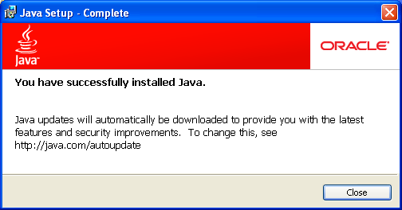

2.1 Zuoz Atom Library distribution:

Zuoz atoms are distributed as individual files which are organized in separate directories based on their characteristics.There are 5 basic categories.
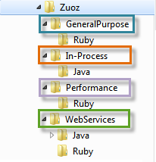
- General Purpose Atoms are written in Ruby.
- In-Process Atoms are written in Java.The zuoz-inprocess.jar contains Zbrowser and Zstring and other atoms.
- 2.Performance Atoms are written in Ruby.
- 3.Web Application atoms are written in Ruby.
- 4.Web Service related atoms written in Ruby and Java.

2.2 Zuoz Set Up with Zug

ZugINI Configuration for Zuoz
Zug can call the external java jar files as builtin atoms through chur spreadsheet. To make it happen the ZugINI.xml parsing is need. Inside the Zug installation directory the ZugINI.xml file can be edited to by putting the values in the tags.
To set up zuoz, kindly insert the following inputs as shown below:

<inprocesspackage>
< inprocesspackage language="java" name="Zbrowser">
<file-path>C:\Programfiles\Automature\ZUOZ\Builtins</file-path>
<jar-package>com.automature.zuoz.builtins.zbrowser</jar-package>
<class-name>BrowserOperations</class-name>
</inprocesspackage>

2.3 Zuoz Set Up for different packages

To add various external jar files, please insert the packages in the following way:

ZXML Package
<inprocesspackage language="java" name="ZXml">
<file-path>C:\Program Files\Automature\ZUOZ\Builtins</file-path>
<jar-package>com.automature.zuoz.inprocess.zxml</jar-package>
<class-name>XMLOperation</class-name>
</inprocesspackage>

ZREST Package
<inprocesspackage language="java" name="ZRest">
<file-path>C:\Program Files\Automature\ZUOZ\Builtins</file-path>
<jar-package>com.automature.zuoz.inprocess.zrest</jar-package>
<class-name>WebServiceOperation</class-name>
</inprocesspackage>

ZFileOps Package
<inprocesspackage language="java" name="ZFileOps">
<file-path>C:\Program Files\Automature\ZUOZ\Builtins</file-path>
<jar-package>com.automature.zuoz.inprocess.zfileops</jar-package>
<class-name>FileOperation</class-name>
</inprocesspackage>

ZString Package
<inprocesspackage language="java" name="ZString">
<file-path>C:\Program Files\Automature\ZUOZ\Builtins</file-path>
<jar-package>com.automature.zuoz.inprocess.zstring</jar-package>
<class-name>StringOperation</class-name>
</inprocesspackage>

ZJSON Package
<inprocesspackage language="java" name="ZJson">
<file-path>C:\Program Files\Automature\ZUOZ\Inprocess</file-path>
<jar-package>com.automature.zuoz.inprocess.zjson</jar-package>
<class-name>JSONOperation</class-name>
</inprocesspackage>

ZDB Package
<inprocesspackage language="java" name="ZDB">
<file-path>C:\Program Files\Automature\ZUOZ\Inprocess</file-path>
<jar-package>com.automature.zuoz.inprocess.zdb</jar-package>
<class-name>DBOperation</class-name>
</inprocesspackage>

ZFTP Package
<inprocesspackage language="java" name="ZFTP">
<file-path>C:\Program Files\Automature\ZUOZ\Inprocess</file-path>
<jar-package>com.automature.zuoz.inprocess.zftpops</jar-package>
<class-name>FtpOperation</class-name>
</inprocesspackage

Web Application Based Atoms

All the Atoms in this section are available in Zbrowser In process package file. These atoms are referenced in CHUR spreadsheet as Zbrowser.<atomname> because of the mapping done in ZugINI.xml.

3.1 Browser Launch Related Atoms

Many of the software applications today are written as web-based applications to be run in an Internet browser. Thus the first step of automation is to launch various browsers and test the applications in different platforms. There are various atoms in zuoz which launch different browsers with a given URL.

3.1.1 OpenBrowserWithUrl

Description
Creates an instance of a IE browser in Windows platform. or Firefox browser if in Linux Platform and navigates to a particular URL, then returns the browser handle into a context variable.

Returned Messages:
- Error while putting driver object in hash list = Browser object has not been instantiated
- Error while finding browser with given url = Url not found

Supported Browsers:
Default browser for each operating system i.e. Internet Explorer in Windows Platform and Firefox in Linux/Ubuntu Platform.

Parameter Name | Purpose | Type | Valid Values | Direction | Optional?
URL | Address of the webpage to be opened in browser. | Scalar | Valid string representing a URL | Input | Required
BrowserHandle | Name of context variable, where window handle can be returned. | Scalar | any ASCII word | Output | Required

Example:

Zbrowser.OpenBrowserWithUrl("http://www.google.com", handle)

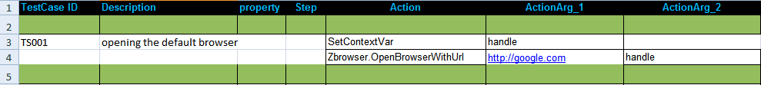

In the above example we show how to open http://google.com in the default browser of an operating system in a chur spreadsheet.

In the first line, we declare a context variable named handle.
In the next line we call the Atom as Zbrowser.OpenbrowserWithUrl with the arguments URL and the handle. The window handle of the browser is stored in this context variable named handle.

3.1.2 Initialize

Description
Creates an instance of the browser and returns the window handle of the browser into a context variable.
For the firefox browser, it is possible to choose a specific user profile for the browser, to inherit custom settings that control behavior of the browser. Please see section 3.1.6 for more information.

Returned Messages:
- Error while creating Firefox object = Invalid name of the browser
- Error while putting firefox driver object in hash list = Firefox object has not been instantiated
- Error while putting firefox driver handle in children hash list = Could not find the instance of firefox in the memory location
- Error while creating IE object = Invalid name of the browser
- Error while putting IE driver object in hash list = IE object has not been instantiated
- Error while putting IE driver handle in children hash list = Could not find the instance of IE in the memory location

Supported Browsers:
To initialize a browser , kindly give any one of the inputs in ActionArg_2 column :
Internet Explorer : ie
Mozilla Firefox : firefox
Google Chrome : chrome

For Browser-less operation:
Html Unit Driver : htmlunit

Parameter Name | Purpose | Type | Valid Values | Direction | Optional?
BrowserHandle | Name of context variable, where window handle can be returned. | Scalar | any ASCII word | Output | Required
Browser | Name of the browser whose instance has to be created . | Scalar | Valid string representing name of the browser | Input | Required

Example:
Zbrowser.Initialize(handle,"firefox")
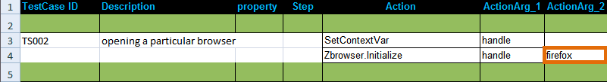

In the above example we show how to open a particular browser in a chur spreadsheet.

In the first line, we declare a context variable named handle.
In the next line we call the Atom as Zbrowser.Initialize with the arguments handle and the browser name firefox. The window handle of the browser is stored in this context variable named handle.

To be noted: This atom simply launches a user defined browser WITHOUT opening any page.

3.1.3 GoToURL

Description

Goes to a particular URL

Returned Messages:

Error while getting to an URL =Cannot navigate to page with the given url

Supported Browsers:

Internet Explorer, Mozilla Firefox, Google Chrome,

For Browser-less operation:
Html Unit Driver : htmlunit

Parameter Name | Purpose | Type | Valid Values | Direction | Optional?
BrowserHandle | Browser handle of window or a frame, where link is to be clicked is located. | Scalar | valid window handle returned by OpenBrowserWithUrl or Initialize | Input | Required
Url | A valid URL where the control has to navigate. | Scalar | string representing valid URL of a page | Input | Required

Example:

Zbrowser.GoToURL(%handle%, "Url of the Navigating page")
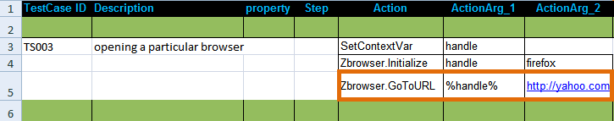

In the above example we show how to navigate to a particular URL.
In the first two lines we simply open a firefox browser which returns the value of the windoe handle to the context variable handle.
In the next line we call the Atom Zbrowser.GoToURL with the value of the window handle and the URL.

To be noted: This atom needs the value of the window handle. Hence to execute this atom, one must call any of the atoms OpenBrowserWithUrl or Initialize first.

3.1.4 FindBrowserWithTitle

Description
Finds a browser with a given title and returns the browser handle into a context variable

Example:

Zbrowser.FindBrowserWithTitle(“google", handle)

Returned Messages:
- Error while getting children window handle=Window handle for new popup couldn't be found
- Error while getting children window titles= Window title for new popup couldn't be found
- Cannot find new window with the given title=Title entered for the new window couldn't be found

Supported Browsers:
Internet Explorer, Mozilla Firefox, Google Chrome

For Browser-less operation:
Html Unit Driver : htmlunit
Parameter Name | Purpose | Type | Valid Values | Direction | Optional? | Default Value
Title | Title of the browser window to find. | Scalar | any string representing a valid title | Input | Required | none
BrowserHandle | Name of context variable, where window handle can be returned. | Scalar | any ASCII word | Output | Required | none

3.1.5 WaitForWindow

Description
Waits for the input window title till it appears or the time out expires.

Example:
Zbrowser.WaitForWindow(“%handle%”, “PageTitle”, “30”)

Supported Browsers:
Internet Explorer, Mozilla Firefox, Google Chrome

For Browser-less operation:
Html Unit Driver : htmlunit
Parameter Name | Purpose | Type | Valid Values | Direction
BrowserHandle | Browser handle of window or a frame | Scalar | valid window handle returned by OpenBrowserWithUrl or Initialize | Input
Title | Name of the page title for which it will wait | Scalar | ASCII string (word) | Input
Time | The maximum time limit the atom will wait for the window title to appear | Scalar | In Second | Input

Returned Messages:
- Error while finding the new window title=Page title couldn't be found
- Error since time out has expired= Page title couldn't be found

3.1.5.1 WaitForWindow

Description
Waits for a page element till it appears or the time out expires. You can search for

Example:
Zbrowser.WaitForWindow(%handle%,,”id”,“PageTitle”, “30”)

Supported Browsers:
Internet Explorer, Mozilla Firefox, Google Chrome

For Browser-less operation:
Html Unit Driver : htmlunit
Parameter Name | Purpose | Type | Valid Values | Direction
BrowserHandle | Browser handle of window or a frame | Scalar | valid window handle returned by OpenBrowserWithUrl or Initialize | Input
Attribute Name | Type of the attribute for which it will wait | Scalar | Id,name,xpath | Input
Attribute Value | Corresponding value of the attribute. | Scalar | any ASCII word | Input
Time | The maximum time limit the atom will wait for the window element to appear | Scalar | In Second | Input

Returned Messages:
- AtomExecutionException message logged in log error file and the error message shown in console.

3.1.6 SetFirefoxProfile

Description
It sets a custom profile for firefox.

Example:
Zbrowser.SetFirefoxProfile(“Profilename”)

Supported Browsers:
Mozilla Firefox

Parameter Name | Purpose | Type | Valid Values | Direction | Optional? | Default Value
ProfileName | Specifies the name of the profile for firefox | Scalar | Valid Firefox Profile Names | Input | Required | none

3.1.7 CloseBrowser

Description
It closes the browser.

Example:
Zbrowser.CloseBrowser(%BrowserHandle%)

Returned Messages:
Error while closing Browser=Text field id is invalid

Supported Browsers:
Internet Explorer, Mozilla Firefox, Google Chrome

For Browser-less operation:
Html Unit Driver : htmlunit

Parameter Name | Purpose | Type | Valid Values | Direction | Optional? | Default Value
BrowserHandle | Browser handle of window or a frame to be closed. | Scalar | valid window handle returned by OpenBrowserWithUrl | Input | Required | none

3.1.8 GetFrameHandle

Description
Returns the handle of a frame (using the frame id or its name) in a context variable.

Example:
Zbrowser.GetFrameHandle(%BrowserHandle%, “Frame”, “Result”)

Returned Messages:
AtomExecutionException message logged in log error file and the error message shown in console.

Supported Browsers:
Internet Explorer, Mozilla Firefox, Google Chrome

For Browser-less operation:
Html Unit Driver : htmlunit

Parameter Name | Purpose | Type | Valid Values | Direction | Optional?
BrowserHandle | Browser handle of window or a frame where the frame exists. | Scalar | valid window handle returned by OpenBrowserWithUrl | Input | Required
Frame | The name or the identifier of the frame. | Scalar | Name or ID | Input | Required
Result | The name of the context variable where the handle of the frame is returned. | Scalar | Valid string representing name of the frame. | Output | Required

3.2 Text Field Related Atoms

The following atoms are used to read and write text in a webpage.

3.2.1 SetTextByName

Description
Set text in a text field by its Name

Returned Messages:
- Error while finding element by text field name=Text field name is invalid
- Error while setting text field with value=Value cannot be inserted at the specified field

Supported Browsers:
Internet Explorer, Mozilla Firefox, Google Chrome

For Browser-less operation:
Html Unit Driver : htmlunit

Parameter Name | Purpose | Type | Valid Values | Direction | Optional? | Default Value
BrowserHandle | Browser handle of window or a frame, where field to be populated is located. | Scalar | valid window handle returned by OpenBrowserWithUrl | Input | Required | none
FieldName | Internal name of the field control. | Scalar | string representing a valid form field name | Input | Required | none
Text | Text to be entered. | Scalar | any string | Input | Required | none

Example:

Zbrowser.SetTextByName(%BrowserHandle%, “Field Description”, “Text”)
The following description shows how to search your desired text in Google. The Action_arg2 in the 5th Row is “q”. This is the search field description of the webpage google.com.The Search_Text is your desired text that you want to search which should be defined in the macros sheet.
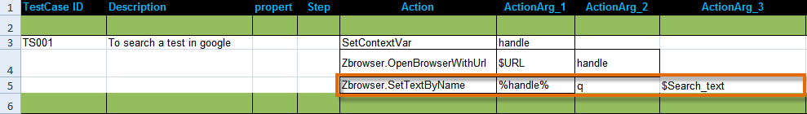

3.2.2 SetTextById

Description
Set text in a text field by its Id

Returned Messages:
- Error while finding element by text field id=Text field id is invalid
- Error while setting text field with value=Value cannot be inserted at the specified field id

Supported Browsers:
Internet Explorer, Mozilla Firefox, Google Chrome, Html Unit Driver

Parameter Name | Purpose | Type | Valid Values | Direction | Optional? | Default Value
BrowserHandle | Browser handle of window or a frame, where field to be populated is located. | Scalar | valid window handle returned by OpenBrowserWithUrl | Input | Required | none
FieldId | Internal ID of form field control. | Scalar | string representing a valid form field ID | Input | Required | none
Text | Text to be entered. | Scalar | any string | Input | Required | none

Example:
Zbrowser.SetTextById(%BrowserHandle%, "FieldId","Text")

3.2.3 SetTextByIndex

Description
Set text in a text field by its tab index.

Returned Messages:
- Error while finding element by text field index=Text field index is invalid
- Error while setting text field with value=Value cannot be inserted at the specified field

Supported Browsers:
Internet Explorer, Mozilla Firefox, Google Chrome, Html Unit Driver

Example:
Zbrowser.SetTextByIndex(%BrowserHandle%, 3,"atom library add-on for zug")

Parameter Name | Purpose | Type | Valid Values | Direction | Optional? | Default Value
BrowserHandle | Browser handle of window or a frame, where field to be populated is located. | Scalar | valid window handle returned by OpenBrowserWithUrl | Input | Required | none
FieldName | Tab index position of the text field | Scalar | Integer representing any tab index position | Input | Required | none
Text | Text to be entered. | Scalar | any string | Input | Required | none

3.2.4 SetMultipleTextByName

Description
Sets multiple number of text fields in a page using the name attribute

Returned Messages:
- Error with unequal number of elements in each list=No match found between the field names and the corresponding values
- Error while trying to find Text Field by Name=Invalid field name present in the list
- Error while trying to set Text Field with value=Field Value could not be set at the corresponding invalid field name

Supported Browsers:
Internet Explorer, Mozilla Firefox, Google Chrome, Html Unit Driver

Parameter Name | Purpose | Type | Valid Values | Direction | Optional? | Default Value
BrowserHandle | Browser handle of window or a frame, where the table is located. | Scalar | a valid window handle returned by OpenBrowserWithUrl | Input | Required | none
ListOfNames | List of internal names of the text fields. | Vector | a colon separated list of text field names enclosed within square brackets | Input | Required | none
ListOfText | List of text to be set in text fields. | Vector | a colon separated list of strings enclosed within square brackets | Input | Required | none

Example:
The following example shows how to log into gmail using this atom
Zbrowser.SetMultipleTextByName(%BrowserHandle%, "[Email:Passwd]","[ericviewer:eric6789]" )
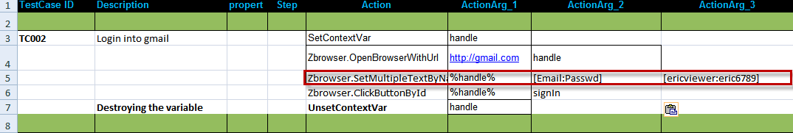

3.2.5 SetMultipleTextById

Description
Sets multiple number of text fields in a page using the id attribute

Returned Messages:
- Error with unequal number of elements in each list=No match found between the field names and the corresponding values
- Error while trying to find Text Field by id=Invalid field id is present in the list
- Error while trying to set Text Field with value=Field Value couldn't be set at the specified invalid field id

Supported Browsers:
Internet Explorer, Mozilla Firefox, Google Chrome, Html Unit Driver

Parameter Name | Purpose | Type | Valid Values | Direction | Optional? | Default Value
BrowserHandle | Browser handle of window or a frame, where the text field is located. | Scalar | a valid window handle returned by OpenBrowserWithUrl | Input | Required | none
ListOfId | List of internal identiferss of the text fields. | Scalar | a colon separated list of text field ids enclosed within square brackets | Input | Required | none
ListOfText | List of text to be set in text fields. | Scalar | a colon separated list of strings enclosed within square brackets | Input | Required | none

Example:
Zbrowser.SetMultipleTextById(%BrowserHandle%, "[Email:Passwd]","[ericviewer:eric6789]" )

3.2.6 SetMultipleFieldTypesByName

Description
Sets multiple number of text fields and select lists in a page

Example:
Zbrowser.SetMultipleFieldTypesByName(%BrowserHandle%, "[product_name:product_id:month:day:year]","[MS-Word:MSW1:June:2:2010]")

Returned Messages:
- Error with unequal number of elements in each list = No match found between the field names and the corresponding values
- Error while trying to find Field by Name = Invalid field name present in the list
- Error while trying to set Field with value = Field Value could not be set at the corresponding invalid field name

Supported Browsers:
Internet Explorer, Mozilla Firefox, Google Chrome, Html Unit Driver
Parameter Name | Purpose | Type | Valid Values | Direction
BrowserHandle | Browser handle of window or a frame, where the text fields and/or select lists are located. | Scalar | a valid window handle returned by OpenBrowserWithURL | Input
ListOfFieldIds | List of names of fields to be set. | Scalar | colon separated list of field names enclosed within square brackets | Input
ListOfTexts | List of text to be set in text fields and/or select lists. | Scalar | colon separated list of texts enclosed within square brackets | Input

3.2.7 SetMultipleTextByIndex

Description
Sets multiple number of text fields in a page using the name attribute

Returned Messages:
- Error with unequal number of elements in each list=No match found between the field names and the corresponding values
- Error while trying to find Text Field by tab Index=Invalid field index present in the list
- Error while trying to set Text Field with index=Field Value could not be set at the corresponding invalid field name

Supported Browsers:
Internet Explorer, Mozilla Firefox, Google Chrome, Html Unit Driver

Parameter Name | Purpose | Type | Valid Values | Direction | Optional? | Default Value
BrowserHandle | Browser handle of window or a frame, where the table is located. | Scalar | a valid window handle returned by OpenBrowserWithUrl | Input | Required | none
ListOfNames | List of tab index position of the text field | Vector | a colon separated list of text field tab indexes enclosed within square brackets | Input | Required | none
ListOfText | List of text to be set in text fields. | Vector | a colon separated list of strings enclosed within square brackets | Input | Required | none

Example:
Zbrowser.SetMultipleTextByName(%BrowserHandle%, "[2:4:5]","[MS-Word:To create text files]"

3.2.8 FindDivText*

3.2.9 GetTagAttributeValueByTagValue*

3.2.10 MatchTextByClassName

Description
Matches the attribute of a tag by its class name with a text. Passes if match found else raises an exception.

Returned Messages:
- Error while finding element by class name=class name is invalid
- Cannot find required text in the given element.

Supported Browsers:
Internet Explorer, Mozilla Firefox, Google Chrome, Html Unit Driver

Parameter Name | Purpose | Type | Valid Values | Direction | Optional? | Default Value
BrowserHandle | Browser handle of window or a frame, where field to be populated is located. | Scalar | valid window handle returned by OpenBrowserWithUrl | Input | Required | none
ClassName | Class name of the tag whose attribute you want to match | Scalar | String representing any class name | Input | Required | none
Text | Text to be entered. | Scalar | any string | Input | Required | none

Example:
Zbrowser.MatchTextByClassName (%BrowserHandle%, “patternViewPage” ,"value")

3.2.11 MatchTextByClassNameWithTimeout*

3.2.12 GetValueOfElement

Description
Retrieves the value of an element in a web page to a context variable by the attribute name and attribute value.
Syntax:
Zbrowser.GetValueofElement(“%BrowserHandle%”, “attribute_name”,“attribute_value”,“Result”)
Example:
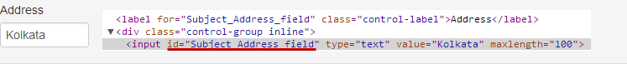
Zbrowser.GetValueofElement(“%handle%”, “id”, “Subject_Address_field”, “result”)
This atom returns the value “Kolkata” in the context variable result.
Returned Messages:
- Failure: AtomExecutionException message logged in log error file and the error message shown in console.

Supported Browsers:
Internet Explorer, Mozilla Firefox, Google Chrome, Html Unit Driver

Parameter Name | Purpose | Type | Valid Values | Direction | Optional? | Default Value
BrowserHandle | Browser handle of window or a frame. | Scalar | valid window handle returned by OpenBrowserWithUrl | Input | Required | none
Attribute_name | The type of attribute | Scalar | Id,xpath,name | Input | Required | none
Attribute_value | Value of the attribute | Scalar | any ASCII string | Input | Required | none
Result | A context variable where the result will be returned | Scalar | any ASCII string | Output | Required | none

3.3 Tables Related Atoms

3.3.1 ClickLinkInTableByRowColumnAndLinkIndex

Description
Clicks a link using the row number, column number and the position of the link within a table.

Returned Messages:
- Error while getting children window handle=Window handle for new popup couldn't be found
- Error while getting children window titles= Window title for new popup couldn't be found
- Cannot find new window with the given title=Title entered for the new window couldn't be found

Supported Browsers:
Internet Explorer, Mozilla Firefox, Google Chrome, Html Unit Driver
Parameter Name | Purpose | Type | Valid Values | Direction | Optional?
BrowserHandle | Browser handle of window or a frame, where the table is located. | Scalar | a valid window handle returned by OpenBrowserWithUrl | Input | Required
TableId | Internal Identifier of the table | Scalar | any string representing a valid table id. | Input | Required
RowNumber | A particular row number within a table,where counting starts from the header row. | Scalar | any positive integer value | Input | Required
ColumnNumber | A particular column number within a table. | Scalar | any positive integer value | Input | Required
Index | A particular index within a table cell,that has the link to be clicked. | Scalar | any positive integer value | Input | Required

Example:
Zbrowser.ClickLinkInTableByRowColumnAndLinkIndex( %BrowserHandle%, "ProductList",%RowNumber%,%ColumnNumber%,"1")

3.3.2 GetRowCountInTable

Description
Returns the number of rows in a table by its table ID, into a context variable

Returned Messages:
- Error while finding table tags=Give table tag couldn't be found
- Cannot find table with the given identifier or invalid table identifier= Table identifier specified couldn't be found on the page

Supported Browsers:
Internet Explorer, Mozilla Firefox, Google Chrome, Html Unit Driver

Parameter Name | Purpose | Type | Valid Values | Direction | Optional?
BrowserHandle | Browser handle of window or a frame, where the table is located. | Scalar | a valid window handle returned by OpenBrowserWithUrl | Input | Required
TableId | Internal Identifier of the table. | Scalar | any string representing a valid table id | Input | Required
RowCount | Returns the number of rows in the table into a context variable. | Scalar | any integer number | Output | Required

Example:
Zbrowser.GetRowCountInTable(%BrowserHandle%,"ProductList",Row_Count)

3.3.3 GetStringOccurrenceCountInTable*

3.3.4 GetTableRowNrByColumnNameAndText

Description
Returns the table row number into a context variable by the name of the column and the text inside that particular column

Returned Messages:
- Error while getting header row in tables=Tag value cannot be found
- Error while selecting cells from header row in table= Attribute with the given name doesn't exist
- Cannot find column name in the first row of the table=Cannot perform click operation as the attribute name doesn't exist
- Error while selecting table rows=Rows not found for the specified column and text
- Error while selecting a cell in table=
- Error cannot find cell with the given text=Cell not present for the test specified

Supported Browsers:
IInternet Explorer, Mozilla Firefox, Google Chrome, Html Unit Driver

Parameter Name | Purpose | Type | Valid Values | Direction | Optional?
BrowserHandle | Browser handle of window or a frame, where the table is located. | Scalar | valid window handle returned by OpenBrowserWithUrl | Input | Required
TableId | Internal Identifier of the table. | Scalar | any string representing a valid table id | Input | Required
ColumnName | Name of the column where the particular text to be searched. | Scalar | any string | Input | Required
TextualContent | Text to be searched inside the table. | Scalar | any string | Input | Required
RowNo | Returns the row number,where the text is found into a context variable. | Scalar | any string representing a valid context variable name | Output | Required

Example:
Zbrowser.GetTableRowNrByColumnNameAndText(%BrowserHandle%, "ProductList", "Product Name", "ZERMATT", RowNumber)

3.3.5 GetTableColumnNrByColumnName

Description
Returns the table column number into a context variable by the name of that column

Returned Messages:
- Error while getting header row in tables=Header specified for the table row couldn't be found
- Error while selecting cells from header row in table= Cells not found for the header specified
- Cannot find column name in the first row of the table=Column name couldn't be found at the row specified
- Cannot find table with the given identifier or invalid table identifier=Table identifier is invalid

Supported Browsers:
Internet Explorer, Mozilla Firefox, Google Chrome, Html Unit Driver

Parameter Name | Purpose | Type | Valid Values | Direction | Optional? | Default Value
BrowserHandle | Browser handle of window or a frame, where the table is located. | Scalar | a valid window handle returned by OpenBrowserWithUrl | Input | Required | none
TableId | Internal Identifier of the table. | Scalar | any string representing a valid table id | Input | Required | none
ColumnName | Name of a column within the table to be searched. | Scalar | any string representing a name of a column | Input | Required | none
ColumnNo | Returns the column number of the particular column into a context variable. | Scalar | any string representing a valid Context Variable name | Output | Required | none

3.3.6 GetTextInTableByRowAndColumnNumber*

3.4 Click Link and Image Related Atoms

3.4.1 ClickLinkBySrc

Description

Clicks a link by its Src

Returned Messages:
- Error while finding Link by Src =Invalid Src
- Error while clicking Link = Timeout for the link has expired

Supported Browsers:
Internet Explorer,Mozilla Firefox,Google Chrome,Html Unit Driver
Parameter Name | Purpose | Type | Valid Values | Direction | Optional? | Default Value
BrowserHandle | Browser handle of window or a frame, where the table is located. | Scalar | a valid window handle returned by OpenBrowserWithUrl | Input | Required | none
Source | Src of the link to be clicked. | Scalar | any string | Input | Required | none

Example:
Zbrowser.ClickLinkBySrc(%BrowserHandle%, "src of the link")

3.4.2 ClickLinkByHref

Description
Clicks a link by its Href

Returned Messages:
- Error while finding Link by href=Invalid Href
- Error while clicking Link=Timeout for the link has expired

Supported Browsers:

Internet Explorer, Mozilla Firefox, Google Chrome, Html Unit Driver

Parameter Name | Purpose | Type | Valid Values | Direction | Optional? | Default Value
BrowserHandle | Browser handle of window or a frame. | Scalar | a valid window handle returned by OpenBrowserWithUrl | Input | Required | none
Href | Hyperlink reference of the link to be clicked. | Scalar | any string representing a valid Href | Input | Required | none

Example:
Zbrowser.ClickLinkByHref(%BrowserHandle%, "href of the link")

3.4.3 ClickLinkById

Description
Clicks a link by its Id

Returned Messages:
- Error while finding Link by Id=Cannot find link with the given id
- Error while clicking Link=Timeout for the link has expired

Supported Browsers:
Internet Explorer, Mozilla Firefox, Google Chrome, Html Unit Driver

Parameter Name | Purpose | Type | Valid Values | Direction | Optional? | Default Value
BrowserHandle | Browser handle of window or a frame, where link to be clicked is located. | Scalar | valid window handle returned by OpenBrowserWithUrl | Input | Required | none
LinkId | Internal ID of link to be clicked. | Scalar | string representing a valid link ID | Input | Required | none

Example:
Zbrowser.clickLinkById(%BrowserHandle%, "id attribute of the link")

3.4.4 ClickLinkByTagValueAndAttributeNameAndValue

Description
Clicks a link By its tag value, attribute name and value of the link

Returned Messages:
- Error while finding elements with anchor tags =Tag value cannot be found
- Error while finding attribute with attribute name = Attribute with the given name doesn't exist
- Error while clicking attribute with attribute name = Cannot perform click operation as the attribute name doesn't exist

Supported Browsers:
Internet Explorer, Mozilla Firefox, Google Chrome, Html Unit Driver

Parameter Name | Purpose | Type | Valid Values | Direction | Optional? | Default Value
BrowserHandle | Browser handle of window or a frame, where the table is located. | Scalar | a valid window handle returned by OpenBrowserWithUrl | Input | Required | none
TagValue | Name of the starting tag | Scalar | any string representing a valid tag of the link. | Input | Required | none
AttributeName | A particular attribute name present within the tag of the link. | Scalar | any string representing the attribute name for the tag | Input | Required | none
AttributeValue | Attribute value for the corresponding attribute name within tag of the link. | Scalar | any string representing the value for the attribute name | Input | Required | none

Example:
Zbrowser.ClickLinkByTagValueAndAttributeNameAndValue(%BrowserHandle%, "font",title,"Name of the product")

3.4.5 ClickLinkByText

Description
Clicks a link by its Text

Returned Messages:
- Error while finding Link by link text=Lin with the given text doesn't exist
- Error while clicking Link=Click operation fails for the given link

Supported Browsers:
Internet Explorer, Mozilla Firefox, Google Chrome, Html Unit Driver

Parameter Name | Purpose | Type | Valid Values | Direction | Optional? | Default Value
BrowserHandle | Browser handle of window or a frame, where link is to be clicked is located. | Scalar | valid window handle returned by OpenBrowserWithUrl | Input | Required | none
Text | Text displayed on the link to be clicked. | Scalar | string representing a valid link ID | Input | Required | none

Example:
Zbrowser.ClickLinkByText(%BrowserHandle%, "go to page")

3.4.6 ClickImageByTitle

Description
Clicks a link using the title of the image

Example:
Zbrowser.ClickImageByTitle(%BrowserHandle%, "Click Image")

Returned Messages:
- Error while finding Image Tags=Cannot find the respective tag for the image
- Error while clicking link by image title=Click operation fails on the link

Supported Browsers:
Internet Explorer, Mozilla Firefox, Google Chrome, Html Unit Driver

Parameter Name | Purpose | Type | Valid Values | Direction | Optional? | Default Value
BrowserHandle | Browser handle of window or a frame, where link is to be clicked is located. | Scalar | valid window handle returned by OpenBrowserWithUrl | Input | Required | none
Title | Title of the image on the link that is be clicked. | Scalar | string representing a valid ttle | Input | Required | none

3.4.7 ClickImageBySrc

Description
Clicks a link using the src of the image

Returned Messages:
- Error while finding link by Image src = Cannot find the respective tag for the image
- Error while clicking link by image src=Click operation fails on the link

Supported Browsers:
Internet Explorer, Mozilla Firefox, Google Chrome, Html Unit Driver

Parameter Name | Purpose | Type | Valid Values | Direction | Optional? | Default Value
BrowserHandle | Browser handle of window or a frame, where link is to be clicked is located. | Scalar | valid window handle returned by OpenBrowserWithUrl | Input | Required | none
src | Source of the image on the link that is be clicked. | Scalar | string representing a valid image source | Input | Required | none

Example:
Zbrowser.ClickImageByTitle(%BrowserHandle%, "http://google/Preferences/banner.jpg")

3.4.8 ClickElementByXpath

Description
Clicks an element by its xpath.

Supported Browsers:
Internet Explorer, Mozilla Firefox, Google Chrome, Html Unit Driver

Parameter Name | Purpose | Type | Valid Values | Direction | Optional? | Default Value
BrowserHandle | Browser handle of window or a frame, where link is to be clicked is located. | Scalar | valid window handle returned by OpenBrowserWithUrl | Input | Required | none
xpath | Xpath of the element that is be clicked. | Scalar | string representing a valid xpath | Input | Required | none

Example:
Zbrowser.clickElementByXpath(%BrowserHandle%, " //*[@id='RepairData_ExteriorRepairs']/div/button ")
N.B : Replace the '' with ' in the xpath while passing them to the atom.

3.5 Click Button Related Atoms

3.5.1 ClickButtonByValue

Description

Clicks the button in a page by its value

Returned Messages:

Error while finding Button by value = Button Tag Not Found,Cannot Locate the button tag using xpath

Example:

Zbrowser.ClickButtonByValue(%BrowserHandle%, "Value attribute of the button")

Supported Browsers:

Internet Explorer, Mozilla Firefox, Google Chrome, Html Unit Driver

Parameter Name | Purpose | Type | Valid Values | Direction | Optional? | Default Value
BrowserHandle | Browser handle of window or a frame, where link is to be clicked is located. | Scalar | valid window handle returned by OpenBrowserWithUrl | Input | Required | none
Value | Text of the button to be clicked | Scalar | any string | Input | Required | none

3.5.2 ClickButtonByClassName

Description
Clicks a button by the attribute as class name

Returned Messages:
- Error while finding Button by class name=Text field id is invalid
- Error while clicking button by class name=Value cannot be inserted at the specified field id

Supported Browsers:
Internet Explorer, Mozilla Firefox, Google Chrome, Html Unit Driver

Parameter Name | Purpose | Type | Valid Values | Direction | Optional? | Default Value
BrowserHandle | Browser handle of window or a frame. | Scalar | a valid window handle returned by OpenBrowserWithUrl | Input | Required | none
Name | Name of the button to be clicked. | Scalar | any string representing a valid button | Input | Required | none

Example:
Zbrowser.ClickButtonByClassName(%BrowserHandle%, "jump")

3.5.3 ClickButtonByName

Description
Clicks a button by its name

Returned Messages:
- Error while finding Button by name=Text field id is invalid
- Error while clicking button by name=Value cannot be inserted at the specified field id

Supported Browsers:
Internet Explorer, Mozilla Firefox, Google Chrome, Html Unit Driver

Parameter Name | Purpose | Type | Valid Values | Direction | Optional? | Default Value
BrowserHandle | Browser handle of window or a frame. | Scalar | a valid window handle returned by OpenBrowserWithUrl | Input | Required | none
Name | Name of the button to be clicked. | Scalar | any string representing a valid button | Input | Required | none

Example:
Zbrowser.ClickButtonByName(%BrowserHandle%, "jump")

3.5.4 ClickButtonById

Description
Clicks a button by its ID

Returned Messages:
- Error while finding Button by id=Text field id is invalid
- Error while clicking button by id=Value cannot be inserted at the specified field id

Supported Browsers:

Internet Explorer, Mozilla Firefox, Google Chrome,

For Browser-less operation:
Html Unit Driver : htmlunit
Parameter Name | Purpose | Type | Valid Values | Direction | Optional? | Default Value
BrowserHandle | Browser handle of window or a frame, where button to be clicked is located. | literal | valid window handle returned by OpenBrowserWithUrl | Input | Required | none
ButtonId | Internal ID of button to be clicked. | Scalar | string representing a valid button ID | Input | Required | none

Example:
Zbrowser.ClickButtonttonById(%BrowserHandle%, "jump")

3.5.5 ClickRadioById

Description
Clicks a radio button by its unique ID

Supported Browsers:
Internet Explorer, Mozilla Firefox, Google Chrome

Parameter Name | Purpose | Type | Valid Values | Direction | Optional? | Default Value
BrowserHandle | Browser handle of window or a frame, where radio button to be clicked is located. | literal | valid window handle returned by OpenBrowserWithUrl or Initialize atom | Input | Required | none
Radio_ButtonId | Internal ID of radio button to be clicked. | Scalar | string representing a valid button ID | Input | Required | none

Browser-less Operations:
Html Unit Driver : htmlunit

Example:
Zbrowser.ClickRadioById(%BrowserHandle%, "option_1")
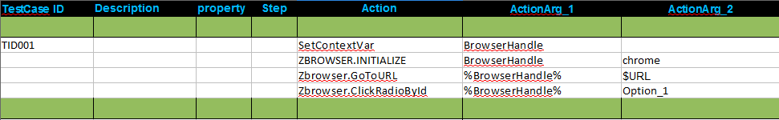
N.B : The unique id of a radio button looks like:
<input type=''radio'' name=''Answer_Options'' id=''Option_1'' value=''Yes''

3.5.6 ClickRadioByNameAndValue

Description
Clicks a radio button by its name and value

Supported Browsers:
Internet Explorer, Mozilla Firefox, Google Chrome, Html Unit Driver

Parameter Name | Purpose | Type | Valid Values | Direction | Optional?
BrowserHandle | Browser handle of window or a frame. | Scalar | a valid window handle returned by OpenBrowserWithUrl  or Initilize atom | Input | Required
Name | Name of the radio button to be selected | Scalar | any string representing a valid button | Input | Required
Value | Value of the corresponding name of the radio button to be clicked | Scalar | any string representing a valid button value

Example:
Zbrowser.ClickRadioByNameAndValue(%BrowserHandle%, "sex”, “male”)

3.5.7 ClickButtonByText

Description
Clicks a button by its Text

Returned Messages:
- Error while finding Button by Text=Text field id is invalid
- Error while clicking button by Text=Value cannot be inserted at the specified field id

Supported Browsers:

Internet Explorer, Mozilla Firefox, Google Chrome,

For Browser-less operation:
Html Unit Driver : htmlunit
Parameter Name | Purpose | Type | Valid Values | Direction | Optional? | Default Value
BrowserHandle | Browser handle of window or a frame, where button to be clicked is located. | literal | valid window handle returned by OpenBrowserWithUrl | Input | Required | none
ButtonText | Text Field within the button tags | Scalar | string representing a valid button ID | Input | Required | none

Example:
Zbrowser.ClickButtonByText(%BrowserHandle%, "Submit")

3.6 DropDown Related Atoms

3.6.1 SelectFromDropDownByName

Description
Select value in Dropdownlist located in Table

Returned Messages:
- Error while finding dropdown by Name=Dropdown name for the field is invalid
- Error while setting dropdown with value=Dropdown value not present in the list

Supported Browsers:
Internet Explorer, Mozilla Firefox, Google Chrome, Html Unit Driver

Parameter Name | Purpose | Type | Valid Values | Direction | Optional? | Default Value
BrowserHandle | Browser handle of window or a frame, where the table is located. | Scalar | a valid window handle returned by OpenBrowserWithURL | Input | Required | none
Name ofDropdownList | Value of dropdownlist name. | Scalar | valid dropdownlist name | Input | Required | none
Value ofDropdownList | Value of dropdownlist. | Scalar | valid dropdownlist value | Input | Required | none

Example:
Zbrowser.SelectFromDropdownbyName(%BrowserHandle%,"table1","2")

3.6.2 SelectFromDropDownById

Description
Select from multiple options in a dropdown list by ID

Returned Messages:
- Error while finding dropdown by Id = Invalid drop down id
- Error while setting dropdown as value =Given drop down text not found

Supported Browsers:
Internet Explorer, Mozilla Firefox, Google Chrome, Html Unit Driver

Parameter Name | Purpose | Type | Valid Values | Direction | Optional? | Default Value
BrowserHandle | Browser handle of window or a frame, where drop down control is located. | Scalar | valid window handle returned by OpenBrowserWithUrl | Input | Required | none
DropdownId | Internal ID of dropdown control. | Scalar | string representing a valid dropdown control | Input | Required | none
OptionId | Internal ID representing option to choose. | Scalar | string representing a valid choice | Input | Required | none

Example:
Zbrowser.SelectFromDropDownById(%BrowserHandle%, "dropdown1","ZERMATT")

3.6.3 SelectFromDropDownByNameUsingText

Description

Selects from the drop down list using their names

Returned Messages:

Error while finding dropdown by Name = Invalid drop down id

Error while setting dropdown with text =Drop down Text not found

Supported Browsers:

Internet Explorer, Mozilla Firefox, Google Chrome, Html Unit Driver

Parameter Name | Purpose | Type | Valid Values | Direction | Optional? | Default Value
BrowserHandle | Browser handle of window or a frame, where dropdown is located. | Scalar | valid window handle returned by OpenBrowserWithUrl | Input | Required | none
DropDown Name | Internal ID of dropdown control. | Scalar | string representing a valid dropdown control | Input | Required | none
DropDown Text | Text representing option to choose. | Scalar | any text string | Input | Required | none

Example:

Zbrowser.SelectFromDropDownByNameUsingText(%BrowserHandle%,"product_id", "MYPRODUCT")

3.6.4 SelectFromMultipleDropDownByName

Description
Selects multiple number of dropdown lists using their name

Returned Messages:

Error while finding dropdown by Name = Invalid drop down name

Error while setting dropdown with value =Drop down Value not found
- Error with unequal number of elements in each list=No match found between the field names and the corresponding values

Supported Browsers:

Internet Explorer, Mozilla Firefox, Google Chrome, Html Unit Driver

Parameter Name | Purpose | Type | Valid Values | Direction | Optional?
BrowserHandle | Browser handle of window or a frame, where the dropdown is located. | Scalar | a valid window handle returned by OpenBrowserWithUrl | Input | Required
ListOfDropDownNames | List of internal names of the dropdowns | Scalar | a colon separated list of dropdown values enclosed within square brackets | Input | Required
ListOfDropdownText | List of visible texts representing options to choose from each dropdown element | Scalar | a colon separated list of strings enclosed within square brackets | Input | Required

Example
Zbrowser.SelectFromMultipleDropDownByName(%BrowserHandle%,"[Country:State:City]","[India:Maharashtra:Mumbai]" )

3.6.5 SelectFromMultipleDropDownById

Description
Selects multiple number of dropdown lists using their Id.

Returned Messages:

Error while finding dropdown by Id = Invalid drop down Id

Error while setting dropdown with Id =Drop down Id not found
- Error with unequal number of elements in each list=No match found between the field names and the corresponding values

Supported Browsers:

Internet Explorer, Mozilla Firefox, Google Chrome, Html Unit Driver
Parameter Name | Purpose | Type | Valid Values | Direction | Optional?
BrowserHandle | Browser handle of window or a frame, where dropdown is located. | Scalar | a valid window handle returned by OpenBrowserWithUrl | Input | Required
ListOfDropDownId | List of internal identifiers of the dropdowns | Scalar | a colon separated list of text field ids enclosed within square brackets | Input | Required
ListOfDropdownText | List of texts representing options to choose from each dropdown element | Scalar | a colon separated list of strings enclosed within square brackets | Input | Required

Example
zbrowser.SelectFromMultipleDropDownById(%BrowserHandle%,"[CountryId:StateId:CityId]","[India:Maharashtra:Mumbai]" )

3.6.6 MatchFromDropDownByName

Description

Matches whether inputted value is present in Dropdownlist.

Returned Messages:

Error while finding Dropdown = Invalid drop down id

Error while Matching Dropdown value = Drop Down text not found

Supported Browser:

Internet Explorer,Mozilla Firefox,Google Chrome,Html Unit Driver

Parameter Name | Purpose | Type | Valid Values | Direction | Optional? | Default Value
BrowserHandle | Browser handle of window or a frame, where dropdown is located. | Scalar | valid window handle returned by OpenBrowserWithUrl | Input | Required | none
DropdownlistName | Name of the Dropdown List. | Scalar | any valid dropdownlist name | Input | Required | none
DropdownValue | Value to be searched in Dropdown. | Scalar | Any valid Dropdown value | input | Required | none

Example:
Zbrowser.MatchFromDropDownByName(%BrowserHandle%,"product_id", "MYPRODUCT")

3.6.7 SelectFromDropDownByIdAndValue

Description
Select from multiple options in a dropdown list by its unique value after selecting the dropdown with its ID.

Returned Messages:
- Error while finding dropdown by Id = Invalid drop down id
- Error while setting dropdown as value =Given drop down value not found

Supported Browsers:
Internet Explorer, Mozilla Firefox, Google Chrome, Html Unit Driver

Parameter Name | Purpose | Type | Valid Values | Direction | Optional? | Default Value
BrowserHandle | Browser handle of window or a frame, where drop down control is located. | Scalar | valid window handle returned by OpenBrowserWithUrl | Input | Required | none
DropdownId | Internal ID of dropdown control. | Scalar | string representing a valid dropdown control | Input | Required | none
OptionId | Value of the visible option to be chosen. | Scalar | string representing a valid choice | Input | Required | none

Example:
Zbrowser.SelectFromDropDownById(%BrowserHandle%, "dropdown1","1")

N.B: In the above example 1 is the id for visible text ''ZERMATT''.

3.6.8 SelectMultipleFromDropDownByIdAndValue

Description
It select value from multiple Drop-Down list by its Id.

Returned Messages:
- Error while finding dropdown by Id = Invalid drop down id
- Error while setting dropdown as value =Given drop down value not found

Supported Browsers:
Internet Explorer, Mozilla Firefox, Google Chrome, Html Unit Driver

Parameter Name | Purpose | Type | Valid Values | Direction | Optional? | Default Value
BrowserHandle | Browser handle of window or a frame, where drop down control is located. | Scalar | valid window handle returned by OpenBrowserWithUrl | Input | Required | none
DropdownId | Internal ID of dropdown control. | Scalar | string representing a valid dropdown control | Input | Required | none
OptionId | Value of the visible option to be chosen. | Scalar | string representing a valid choice | Input | Required | none

Example:
Zbrowser.SelectFromDropDownById(%BrowserHandle%, "[car:country:Product]","[audi:USA:zuoz]")

3.7 Alert Box and List Box Related Atoms

3.7.1 AcceptAlert

Description
Accepts the Alert by clicking on OK button within a default timeout

Returned Messages:
- Error while switching to alert window = Handle of the alert not found
- Error while clicking OK button in alert window = Default time out set as 30 milli seconds for the alert has expired

Supported Browsers:
Internet Explorer, Mozilla Firefox, Google Chrome, Html Unit Driver

Parameter Name | Purpose | Type | Valid Values | Direction | Optional? | Default Value
BrowserHandle | Browser handle of window or a frame, where Alert box is located. | Scalar | valid window handle returned by OpenBrowserWithUrl | Input | Required | none

Example:
Zbrowser.AcceptAlert(%BrowserHandle%)

3.7.2 AcceptAlertWithTimeOut

Description
Accepts the Alert by clicking on OK button within a specific time out

Returned Messages:
- Error while switching to alert window = Handle of the alert not found
- Error while clicking OK button in alert window =Time out for the alert has expired

Supported Browsers:
Internet Explorer, Mozilla Firefox, Google Chrome, Html Unit Driver

Parameter Name | Purpose | Type | Valid Values | Direction | Optional? | Default Value
BrowserHandle | Browser handle of window or a frame, where the alert box is located. | Scalar | valid window handle returned by OpenBrowserWithUrl | Input | Required | none
TimeOut | Time out set for the alert in milli seconds. | Scalar | Valid time interval in milli seconds | Input | Required | none

Example:
Zbrowser.AcceptAlertWithTimeOut(%BrowserHandle%, “1000")

3.7.3 DeclineAlert

Description
Decline the Alert by clicking on cancel button within a default time out

Returned Messages:
- Error while switching to alert window = Handle of the alert not found
- Error while dismissing alert = Default time out set as 30 milli seconds for the alert has expired

Supported Browsers:
Internet Explorer, Mozilla Firefox, Google Chrome, Html Unit Driver

Parameter Name | Purpose | Type | Valid Values | Direction | Optional? | Default Value
BrowserHandle | Browser handle of window or a frame, where the alert box is located. | Scalar | valid window handle returned by OpenBrowserWithUrl | Input | Required | none

Example:
Zbrowser.DeclineAlert(%BrowserHandle%)

3.7.4 DeclineAlertWithTimeOut

Description
Decline the Alert by clicking on cancel button within as specific time out

Returned Messages:
- Error while switching to alert window = Handle of the alert not found
- Error while dismissing alert =Time out for the alert has expired

Supported Browsers:
Internet Explorer, Mozilla Firefox, Google Chrome, Html Unit Driver

Parameter Name | Purpose | Type | Valid Values | Direction | Optional? | Default Value
BrowserHandle | Browser handle of window or a frame, where the alert box is located. | Scalar | valid window handle returned by OpenBrowserWithUrl | Input | Required | none
TimeOut | Time out set for the alert in milliseconds. | Scalar | Valid time interval in milliseconds | Input | Required | none

Example:
Zbrowser.DeclineAlertWithTimeOut(%BrowserHandle%,"1000")

3.7.5 GetTextInAlert

Description
Returns the text of a alert box

Returned Messages:
- Error while switching to alert box=Cannot get the alert box handle
- Error while retrieving text in alert box=Cannot read text from the alert box

Supported Browsers:
Internet Explorer, Mozilla Firefox, Google Chrome, Html Unit Driver

Parameter Name | Purpose | Type | Valid Values | Direction | Optional? | Default Value
BrowserHandle | Browser handle of window or a frame, where the pop up is raised. | Scalar | a valid window handle returned by OpenBrowserWithUrl | Input | Required | none
PopupText | Returns the text in pop up into this context variable. | Scalar | any string | Output | Required | none

Example:
Zbrowser.GetTextInAlert(%BrowserHandle%, AlertText)

3.7.6 GetTextInAlertWithTimeOut

Description
Returns the text of a popup in a context variable within a specific time out

Returned Messages:
- Error while switching to alert = Cannot get the handle of the alert box
- Error while retrieving text in alert = Cannot read text from the alert box
- Alert not supported = Alerts are by default disabled

Supported Browsers:
Internet Explorer, Mozilla Firefox, Google Chrome, Html Unit Driver

Parameter Name | Purpose | Type | Valid Values | Direction | Optional?
BrowserHandle | Browser handle of window or a frame, where the pop up is raised. | Scalar | a valid window handle returned by OpenBrowserWithUrl | Input | Required
AlertText | Returns the text in alert into this context variable. | Scalar | any string | Output | Required
TimeOut | Time out set for the alert in milli seconds. | Scalar | Valid time interval in milli seconds | Input | Required

Example:
Zbrowser.GetTextInAlertWithTimeOut(%BrowserHandle%,AlertText,"100")

3.7.7 SelectFromListBoxByName

Description

Selects from the list box using the names present

Returned Messages:

Error while finding ListBox by Name = Invalid list box id

Error while setting ListBox with value = Text under list box not found

Supported Browsers:

Internet Explorer, Mozilla Firefox, Google Chrome, Html Unit Driver

Parameter Name | Purpose | Type | Valid Values | Direction | Optional? | Default Value
BrowserHandle | Browser handle of window or a frame, where list box is located | Scalar | valid window handle returned by OpenBrowserWithUrl | Input | Required | none
ListBoxName | Name of ListBox. | Scalar | any valid listbox name | Input | Required | none
ListBoxValue | The value to be checked whether it is present in the ListBox | Scalar | any valid input | Input | Required | none

Example:

Zbrowser.SelectFromListBoxByName(%BrowserHandle%,"list_box_name", "MYNAME")

3.7.8 SelectFromListBoxById

Description

Selects an option from the list box using the Id.

Returned Messages:

Error while finding ListBox by Id = Invalid list box id

Error while setting ListBox with value = Text under list box not found

Supported Browsers:

Internet Explorer, Mozilla Firefox, Google Chrome, HtmlUnit Driver

Parameter Name | Purpose | Type | Valid Values | Direction | Optional? | Default Value
BrowserHandle | Browser handle of window or a frame, where list box is located | Scalar | valid window handle returned by OpenBrowserWithUrl | Input | Required | none
ListBoxId | Id of the ListBox. | Scalar | any valid listbox Id | Input | Required | none
ListBoxValue | The value to be checked whether it is present in the ListBox | Scalar | any valid input | Input | Required | none

Example:

Zbrowser.SelectFromListBoxById(%BrowserHandle%,"list_box_Id", "MYNAME")

3.8 Verification Atoms for Web Application

3.8.1 MatchRowValuesInTable

Description
Matches a row within a table of specified columns with a list of values

Return Codes:
0 = Success
1 = Cannot find browser with the given browser handle
2 = Unequal number of arguments passed in each list
3 = Table not found
4 = Required row don't exist
5 = Cannot find column with given column name
6 = Values don't match

Supported Browsers
Internet Explorer ,Internet Explorer, Mozilla Firefox

Additional Comments
In CHUR, the column names list and values list must be a colon separated list without inverted commas and within square brackets

Parameter Name | Purpose | Type | Valid Values | Direction | Optional? | Default Value
BrowserHandle | Browser handle of window or a frame, where the table is located. | Scalar | a valid window handle returned by OpenBrowserWithURL | Input | Required | none
TableId | Identifier of the table. | Scalar | any valid table identifier | Input | Required | none
ListOfColumnNames | List of column names whose values of a particular row should be verified. | Scalar | colon separated list of column names enclosed within square brackets | Input | Required | none
ListOfValues | List of expected values in a row. | Scalar | colon separated list of expected values enclosed within square brackets | Input | Required | none
Row_Nr | Row number of the table to be verified. | Scalar | any integer value | Input | Required | none

Example
MatchRowValuesInTable(%BrowserHandle%, "ProductList","[Name:Description:Place:Date]","[ZUOZ:Atom Library Addon:05-03-2010]","3")

3.8.2 MatchFromDropDownByName

Description
Matches whether inputted value is present in Dropdownlist.

Return Codes:
0 = Success
1 = Cannot find browser with the given browser handle
2 = Cannot find select list with the given Id or invalid select list Id
3 = Sum of text field values do not match with the value of the last text field
4= No Values in DropDown match given value

Supported Browsers
Internet Explorer, Mozilla Firefox

Parameter Name | Purpose | Type | Valid Values | Direction | Optional?
BrowserHandle | Browser handle of window or a frame, where the dropdown is located. | Scalar | a valid window handle returned by OpenBrowserWithURL | Input | Required
DropdownlistName | Name of the Dropdown List. | Scalar | any valid dropdownlist name | Input | Required
DropdownValue | Value to be searched in Dropdown. | Scalar | Any valid Dropdown value | input | Required

Example
MatchFromDropDownByName(%BrowserHandle%,"Dropdown1","value1")

3.8.3 MatchFromListBoxByName

Description
Matches whether inputted value is present in Listbox.

Return Codes:
0 = Success
1 = Cannot find browser with the given browser handle
2 = Cannot find select list with the given Id or invalid select list Id
3= No Values in ListBox match given value

Supported Browsers
Internet Explorer, Mozilla Firefox,

Additional Comments
Support for Firefox will follow shortly

Parameter Name | Purpose | Type | Valid Values | Direction | Optional? | Default Value
BrowserHandle | Browser handle of window or a frame, where the listbox is located. | Scalar | a valid window handle returned by OpenBrowserWithURL | Input | Required | none
ListBoxName | Name of the Listbox. | Scalar | any valid listbox name | Input | Required | none
ListBoxValue | Value to be searched in Listbox. | Scalar | Any valid Listboxvalue | input | Required | none

Example
MatchFromListBoxByName(%BrowserHandle%,"Listbox1","value1")

3.8.4 MatchFromRadioGroupByValue

Description
Matches whether radiogroup with given value is checked.

Return Codes:
0 = Success
1 = Cannot find browser with the given browser handle
2 = Cannot find radio group with the given value

Supported Browsers
Internet Explorer, Mozilla Firefox

Parameter Name | Purpose | Type | Valid Values | Direction | Optional? | Default Value
BrowserHandle | Browser handle of window or a frame, where the radio group is located. | Scalar | a valid window handle returned by OpenBrowserWithURL | Input | Required | none
RadioGroupValue | Value of the radio group to be checked. | Scalar | any valid radiogroup value | Input | Required | none

Example

MatchFromRadioGroupByValue(%BrowserHandle%,"radiovalue1")

3.8.5 VerifyTextualContent

Description
Verifies whether the page contains the particular text or not.

Return Codes:
0 = Success
1 = Cannot find browser with the given browser handle
2 = Page does not contains the text

Supported Browsers
Internet Explorer,Mozilla Firefox

Parameter Name | Purpose | Type | Valid Values | Direction | Optional? | Default Value
BrowserHandle | Browser handle of window or a frame, where the text is located. | Scalar | a valid window handle returned by OpenBrowserWithUrl | Input | Required | none
Text | Verify whether this Text is present within the page or not. | Scalar | any string | Input | Required | none

Example
VerifyTextualContent(%BrowserHandle%, "Can modify planning data on this page")

3.8.6 VerifyDifferenceOfTextFieldValuesById

Description
Computes the difference of two text field values and matches with another text field values

Return Codes:
0 = Success
1 = Cannot find browser with the given browser handle
2 = Cannot work with more the two elements in this list
3 = Cannot find text field with the given id or invalid text identifier
4 = Difference of text field values do not match with the value of the text field in the third argument

Supported Browsers
Internet Explorer, Mozilla Firefox

Additional Comments
In CHUR ,the list of text field identifiers must be a colon separated list without inverted commas and within square brackets

Parameter Name | Purpose | Type | Valid Values | Direction | Optional? | Default Value
BrowserHandle | Browser handle of window or a frame, where the text fields are located. | Scalar | a valid window handle returned by OpenBrowserWithURL | Input | Required | none
ListOfTextFieldIds | List of identifiers to calculate the difference between the two text field values. | Scalar | colon separated list of text field identifiers enclosed within square brackets | Input | Required | none
TextFieldIds | Identifier of the field whose value will be matched with the difference. | Scalar | a valid text field identifier | Input | Required | none

Example
VerifyDifferenceOfTextFieldValuessById(%BrowserHandle%, "[total:discount]","grandtotal]")

3.8.7 VerifyTotalOfNumericFieldsById

Description
Computes the sum of the values of first 'n-1' text field identifiers and matches with the value of 'n'th text field identifier

Return Codes:
0 = Success
1 = Cannot find browser with the given browser handle
2 = Cannot find text field with the given id or invalid text field identifiers
3 = Sum of text field values do not match with the value of the last text field

Supported Browsers
Internet Explorer, Mozilla Firefox

Additional Comments
In CHUR ,the list of text field identifiers must be a colon separated list without inverted commas and within square brackets

Parameter Name | Purpose | Type | Valid Values | Direction | Optional? | Default Value
BrowserHandle | Browser handle of window or a frame, where the text fields are located. | Scalar | a valid window handle returned by OpenBrowserWithURL | Input | Required | none
ListOfTextFieldIds | Read values from this text fields and complete the verification. | Scalar | colon separated list of text field identifiers enclosed within square brackets | Input | Required | none

Example

VerifyTotalOfNumericFieldsById(%BrowserHandle%, "[total:tax:grandtotal]")

General Purpose Atoms

All the Atoms in this section are available in Zstring In process package file. These atoms are referenced in CHUR spreadsheet as ZString.<atom-name> because of the mapping done in ZugINI.xml.

4.1 Compare

Description
Compares two strings (case - insensitive), if matches exits with status 0, else exits with status 1.

Example
Zstring.compare("Hello","Hi")
Zstring.compare("Red”, “Orange”, “The colors are different”)
For the second comparison, Zug will return the following error in the display -
“Red does not match Orange” ; The colors are different.

Return Codes:
0 = Strings match
1 = Strings do not match

Parameter Name | Purpose | Type | Valid Values | Direction | Optional?
FirstString | First value to be compared with | Scalar | any string value | Input | Required
SecondString | Second value to be compared with | Scalar | any string value | Input | Required
Error Message | User defined error message | Scalar | any string value | Input | Optional

4.2 CompareRowCount

Description
It compares the difference of two integer values with an expected value.
It calculates the difference of the first number with the second number and compares it with the third number,if they are same the atom completes successfully else exits with exit status 1

Example
Zstring.compareRowCount("3","1","2")
Zstring. compareRowCount("5","6","-1")

Return Codes:
0 = Difference of first number from the second number matches the expected value
1 = Difference of first number from the second number do not match with the expected value

Parameter Name | Purpose | Type | Valid Values | Direction | Optional? | Default Value
FirstValue | Any number from which the second number will be subtracted | Scalar | any integer number | Input | Required | none
SecondValue | Any number that will be subtracted from the first number | Scalar | any integer number | Input | Required | none
ExpectedValue | Any number to match the difference between the first two values | Scalar | any integer number | Input | Required | none

4.3 MatchSubstring

Description
Verifies whether a sub string is present in a given string.

Example
Zstring.MatchSubstring("Hello","He")
Zstring.MatchSubstring("Hello","llo")

Return Codes:
0 = Sub string is present in the given string
1 = Sub string is not present in the given string
Parameter Name | Purpose | Type | Valid Values | Direction | Optional? | Default Value
ActualString | Actual string | Scalar | any string | Input | Required | none
SubString | To check whether this string is in the actual string. | Scalar | any string | Input | Required | none

4.4 GetElementInListByIndex

Description
Returns an element from a list of elements by its position in a context variable

Return Codes:
0 = Success
1 = Cannot find any element in that position of the list

Additional Comments
In CHUR ,the list of numbers must be a colon separated list without inverted commas and within square brackets

Example
Zstring.GetElementInListByIndex("[ZERMATT:ZUG:ZUOZ:DAVOS:CHUR]","3",ELEMENT)

Parameter Name | Purpose | Type | Valid Values | Direction | Optional? | Default Value
ListOfElements | Colon separated list of elements | Scalar | colon separated valid list of elements enclosed within square brackets | Input | Required | none
ElementPosition | Any position within the list | Scalar | any integer value | Input | Required | none
Element | Returns the element in this context variable | Scalar | any string | Input | Required | none

4.5 getDate

Description
Returns the formatted with '-' Current Date in a context variable.

Return Codes:
0 = Success
1 = Insufficient Arguments

Example
Zstring.getDate("Date")
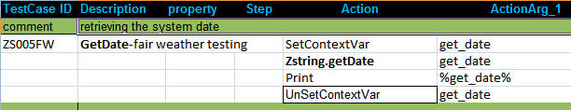

The output in the Console is as follows:

Parameter Name | Purpose | Type | Valid Values | Direction | Optional? | Default Value
Date | A context variable where the system date will be returned. | Scalar | Must be a Context Variables | Input | Required | None

4.6 getTime

Description
Returns the formatted with ':' Current Time in a context variable.

Return Codes:
0 = Success
1 = Insufficient Arguments

Example
Zstring.getTime("Time")

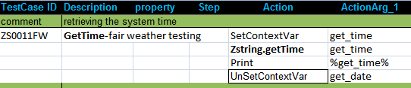

The output for the above testcase will print 15:40:49 in the console

Parameter Name | Purpose | Type | Valid Values | Direction | Optional? | Default Value
Time | A context variable where the system Time will be returned. | Scalar | Must be a Context Variables | Input | Required | None

4.7 CleanUtfBOM

Description
This atom removes Byte Order Marking for UTF-8, UTF-16,UTF-32 character set.

Return Codes:
0 = Success
1 = Insufficient Arguments

Example
Zstring.CleanUtfBOM("Input Context Var Name”, “Output Context Var Name”)

Parameter Name | Purpose | Type | Valid Values | Direction | Optional? | Default Valu
Input Context Variable | Read the content | Scalar | Must be a Context Variables | Input | Required | None
Output Context Variable | Returns the formatted content | Scalar | Must be a Context Variables | Output | Required | None

4.8 GenGUID

Description
Generates unique GUID

Return Codes:
0 = Success
1 = Insufficient Arguments

Example
Zstring.genGUID(GUID_value)

Parameter Name | Purpose | Type | Valid Values | Direction | Optional? | Default Valu
GUID_value | A context variable to store the GUID | Scalar | Any String | Input | Required | None

4.9 Random

Description
Generates a random string and returns it to a context variable.

Example

Zstring.Random(n(3), randomstring)
This returns a 3-digit random number to the context variable.

Parameter Name | Purpose | Type | Valid Values | Direction | Optional?
RandomStringType | Specifies the String length and string type  e.g. numeric, alphanumeric etc | Scalar | Look into the table below | Input | Required
randomstring | To store the random string | Scalar | Any String | Output | Required

Random String Type

Option | Description | Example
n(x) | It creates a x-digit random number. | n(5)=57826
n(x:y) | It creates a number having digits ranging from x to y (where x<y) | n(2:4)=219
A(x) | It creates a string having x no. of uppercase letters | A(4)=SKBT
A(x:y) | A string having uppercase letters whose length ranges from x and y (where x<y) | A(3:6)=PFNYS
a(x) | It creates a string having x no. of lowercase letters | a(2)=kt
a(x:y) | A string having lowercase letters whose length ranges from x and y (where x<y) | a(4:7)=duwvsf
x(z) | It creates an alphanumeric string of length z | x(4)=D5zo
x(m:n) | It creates an alphanumeric string whose length ranges from m and n (where m<n) | X(2:5)=o9sd
R(a,b,c) | It generates a random output from a list of comma separated given inputs. | R(Red,Green,Blue)= Blue

The above options can also be taken together in a string.

Example- Random Telephone number "001-R(11,22,33)-n(4)-n(4)" might generate 001-11-2334-9987"
The following is an example of generating random address
Example -
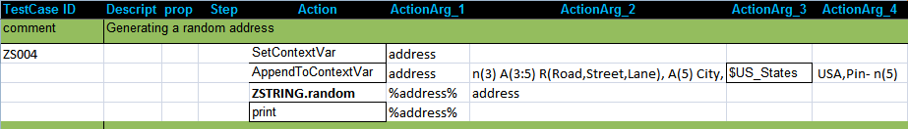

Here $US_States contains a list of all the states of USA.
The output of the above testcase :

The following testcase is an example of generating random name:
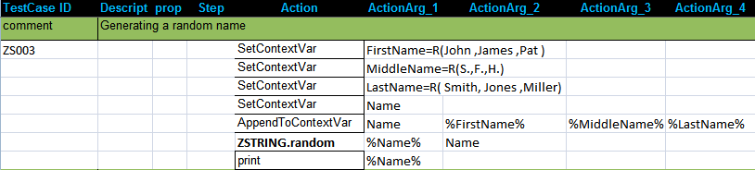

The output of the above testcase:

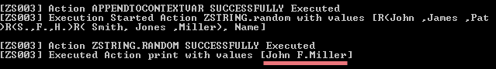

4.10 Eval

Description

Zug has access to a SQLLite Database, which can be accessed without any database credentials.This gives the user direct access to all the SQLLite core functions. This atom converts any formula into a SQL statement, execute it against the SQLLite DB, and returns the result into a context variable.

Here is a link to the SQLITE core functions.
http://www.sqlite.org/lang_corefunc.html .

Syntax:
ZString.Eval(Execute_formula,result)

Example:
ZString.Eval (ltrim('testing','t'), result)

Another Example shown below:

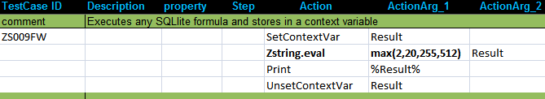

Exception:
Failure: AtomExecutionException message logged in log error file and the error message shown in console.

Parameter Name | Purpose | Type | Valid Values | Direction | Optional?
Execute_formula | Any SQLlite core function | Scalar | Must be any of the formulas stated in this page. | Input | Required
Result | The result of the execution is stored in this context variable. | Scalar | any string | Output | Required

4.11 ChooseByIndex

Description

Returns a particular value from a given list of values separated by a particular symbol by stating the index number and returns it to a context variable.

Syntax:
Zstring.ChooseByIndex(index_number,values,separator,result)

Example:
Zstring.ChooseByIndex(3, Venice#Boston#Dubai#Paris, #, result)

The above result will store the value Dubai.

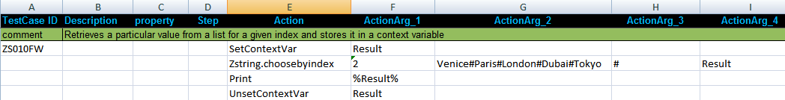

Parameter Name | Purpose | Type | Valid Values | Direction | Optional?
index_number | Index of the value in the list of values | Scalar | any string | Input | Required
values | A String or a list of values separated by a particular symbol | Scalar | any string | Input | Required
separator | The particular symbol which separates the different values in the list | Scalar | any string | Input | Required
result | Returns the value of the desired key in the context variable | Scalar | Any string | Output | Required

4.12 GetEnvVariable

Description

Reads a particular value of the specified environment variable and returns it to a context variable.

Syntax:
Zstring.GetEnvironmentVariable(Env_variable,Result)

Example:
If we want to know the OS of the system then,
Zstring.GetEnvVariable(OS,Env_var_result)

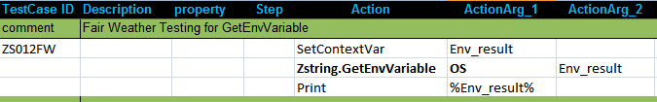

4.12 SetEnvVariable

Description

It sets a given value to a specific environment variable.

Syntax:
Zstring.SetEnvironmentVariable(Env_variable,Your Value)

Example:
Zstring.GetEnvVariable(USERNAME, your_name)

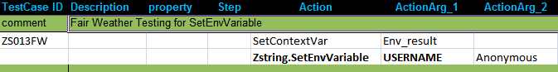

Performance Testing Atoms

The list of Performance Testing Atoms are :
Nr | Name | Purpose
1 | remote_proc_io | Connects to the remote server machine for getting Disk I/O usage for a given process using SSH
2 | remote_proc_net | Connects to the remote server machine for getting net usage for a given process using SSH
3 | remote_proc_net_mb | Connects to the remote server machine for getting net usage for a given process in megabytes using SSH
4 | remote_proc_stat | Connects to the remote server machine for getting CPU usage for a given process using SSH
5 | remote_Zug | Connects to the remote server machine for invoking the zug with specific arguments using SSH

5.1 remote proc_io

Description
Returns the read bytes and write bytes of Disk I/O usage in a remote server machine for a particular process in two different context variables while it takes the inputs of Hostname with port number of ssh server,username,password and the particular process

Example
remote_proc_io("hostname:port","username:password","processname",contextvar1,contextvar2)

Return Codes:
0 = Success
1 = Insufficient Arguments

Additional Comments
A SSH server client is needed. In Chur sheet the all the arguments must be mentioned in the proper way as per the example

Parameter Name | Purpose | Type | Valid Values | Direction | Optional? | Default Value
Hostname:port | Sets the hostname of server machine with port | Vector | any string | Input | Required | :22
username:password | Sets the username and the password of the host machine | Vector | any string | Input | Required | none
processname | Sets the process name on which it fetches the reports on usage of Disk/IO | Scalar | any string | Input | Required | none
context variable | two context variables for storing the recorded reports of read bytes and write bytes | Scalar | any string | Input | Required | none

5.2 remote proc net

Description
Returns the receive bytes and transmit bytes of network usage in a remote server machine for a particular process in two different context variables while it takes the inputs of Hostname with port number of ssh server,username,password and the particular process

Example
remote_proc_net("hostname:port","username:password","processname",contextvar1,contextvar2)

Return Codes:
0 = Success
1 = Insufficient Arguments

Additional Comments
Support for Firefox will follow shortly
A SSH server client is needed. In Chur sheet the all the arguments must be mentioned in the proper way as per the example

Parameter Name | Purpose | Type | Valid Values | Direction | Optional? | Default Value
Hostname:port | Sets the hostname of server machine with port | Vector | any string | Input | Required | :22
username:password | Sets the username and the password of the host machine | Vector | any string | Input | Required | none
processname | Sets the process name on which it fetches the reports on usage of network | Scalar | any string | Input | Required | none
context variable | two context variables for storing the recorded reports of receive bytes and transmit bytes | Scalar | any string | Input | Required | none

5.3 remote proc net mb

Description
Returns the receive bytes and transmit bytes of network usage in a remote server machine for a particular process in two different context variables while it takes the inputs of Hostname with port number of ssh server,username,password and the particular process

Example
remote_proc_net_mb("hostname:port","username:password","processname",contextvar1,contextvar2)

Return Codes:
0 = Success
1 = Insufficient Arguments

Additional Comments
Support for Firefox will follow shortly
A SSH server client is needed. In Chur sheet the all the arguments must be mentioned in the proper way as per the example

Parameter Name | Purpose | Type | Valid Values | Direction | Optional? | Default Value
Hostname:port | Sets the hostname of server machine with port | Vector | any string | Input | Required | :22
username:password | Sets the username and the password of the host machine | Vector | any string | Input | Required | none
processname | Sets the process name on which it fetches the reports on usage of network | Scalar | any string | Input | Required | none
context variable | two context variables for storing the recorded reports of recieve MB and transmit MB | Scalar | any string | Input | Required | none

5.4 remote proc stat

Description
Returns the cpu user time and cpu system time of CPU usage in a remote server machine for a particular process in two different context variables while it takes the inputs of Hostname with port number of ssh server,username,password and the particular process

Example
remote_proc_stat("hostname:port","username:password","processname",contextvar1,contextvar2)

Return Codes:
0 = Success
1 = Insufficient Arguments

Additional Comments

A SSH server client is needed. In Chur sheet the all the arguments must be mentioned in the proper way as per the example

Parameter Name | Purpose | Type | Valid Values | Direction | Optional? | Default Value
Hostname:port | Sets the hostname of server machine with port | Vector | any string | Input | Required | :22
username:password | Sets the username and the password of the host machine | Vector | any string | Input | Required | none
processname | Sets the process name on which it fetches the reports on usage of CPU usage | Scalar | any string | Input | Required | none
context variable | two context variables for storing the recorded reports of cpu user time and cpu system time | Scalar | any string | Input | Required | none

5.5 remote Zug

Description
Connects and executes zug with specific arguments with a specific arguments

Example
remote_Zug("hostname:port","username:password","zug_arguments")

Return Codes:
0 = Success
1 = Insufficient Arguments

Additional Comments
A SSH server client is needed. In Chur sheet the all the arguments must be mentioned in the proper way as per the example
Parameter Name | Purpose | Type | Valid Values | Direction | Optional? | Default Value
Hostname:port | Sets the hostname of server machine with port | Vector | any string | Input | Required | :22
username:password | Sets the username and the password of the host machine | Vector | any string | Input | Required | none
zugargument | Sets the argument on which it executes the remote zug | Scalar | any string | Input | Required | none

Web Service Atoms

All the Atoms in this section are available in ZRest In process package file. These atoms are referenced in CHUR spreadsheet as Zrest.<atom-name> because of the mapping done in ZugINI.xml.

The following atoms can be used to send request and parse the response for any webservice.

6.1 RestClient

Description
Sends the request to a web service (GET, DELETE, POST, PUT and HEAD)

When the method is GET or DELETE, the mode can either FILE or CV ( i.e. a context variable)
When the method is POST or PUT, the mode can be either CV2CV ( context variable to a context variable) or CV2FILE (context variable to a file) or FILE2CV (file to a context variable) or FILE2FILE ( a file to a file).

Example
RestClient("url","GET", response, mode, Content-
Type=text/html;charset=utf-8&&Connection=Keep-Alive, response_header
status)
OR
RestClient("url","DELETE", response, mode, Content-
Type=text/html;charset=utf-8&&Connection=Keep-Alive, response_header
status)

Return Codes:
Success: Response stored in context variable here 'response'
Failure: RestClientException message logged in log error file and message shown in console.

The following are the parameters for GET method:

Parameter Name | Purpose | Type | Valid Values | Direction | Optional? | Default Value
url | First Argument which must be a valid url | Scalar | any string | Input | Required | none
method | Should be GET | Scalar | any string | Input | Required | none
Response | Response data from the server to be returned in it(ContextVariable) | Scalar |  | Output | Required | none
mode | Specifies whether the input and output variables will be context variables or files | Scalar | FILE or CV | Input | Required | none
RequestHeader | Header value to be set | Scalar | Double ampersand (&&)  separated key value pairs or default | Input | Required | default
ResponseHeader | Context variable name  to store the header sent  by the server | Scalar | any string | Output | Optional | none
Status | Context variable name  to store the response  code of the server | Scalar | any string | Output | Optional | none
Example:
The following example shows how to use the GET method to download an image from a given URL. The same image was downloaded manually. The checksum for both the files downloaded manually and the one we got using the GET method were computed and compared for verification. Also the status returned by the RestClient was also compared with the expected status code.

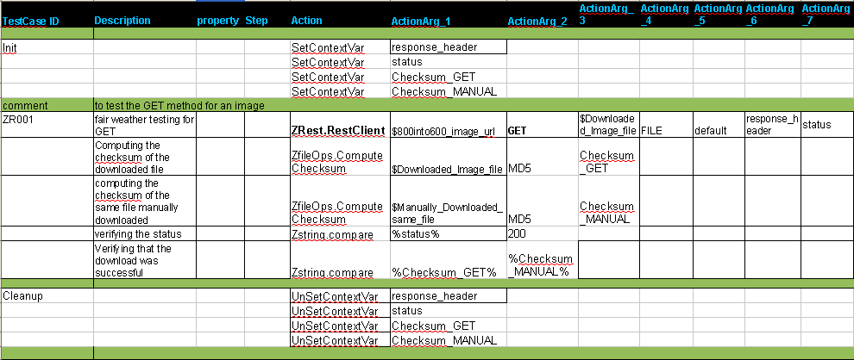

The following are the parameters for DELETE method:

Parameter Name | Purpose | Type | Valid Values | Direction | Optional? | Default Value
url | First Argument which must be a valid url | Scalar | any string | Input | Required | none
method | Should be DELETE | Scalar | any string | Input | Required | none
Response | Response data from the server to be returned in it(ContextVariable) | Scalar | It should be blank. | Output | Required | none
mode | Specifies whether the input and output variables will be context variables or files | Scalar | FILE or CV | Input | Required | none
RequestHeader | Header value to be set | Scalar | Double ampersand (&&)  separated key value pairs or default | Input | Required | default
ResponseHeader | Context variable name  to store the header sent  by the server | Scalar | any string | Output | Optional | none
Status | Context variable name  to store the response  code of the server | Scalar | any string | Output | Optional | none
Example:
The following example shows how to use the DELETE method to delete an image from a given URL.Also the status returned by the RestClient was also compared with the expected status code.

Example
RestClient("url","POST",requestbody, response, mode, Content-
Type=text/html;charset=utf-8&&Connection=Keep-Alive, response_header,
status)
OR
RestClient("url","PUT",requestbody, response, mode, Content-
Type=text/html;charset=utf-8&&Connection=Keep-Alive, response_header,
status)
The following are the parameters for POST method:

Parameter Name | Purpose | Type | Valid Values | Direction | Optional? | Default Value
url | First Argument which must be a valid url | Scalar | any string | Input | Required | none
method | Should be POST | Scalar | any string | Input | Required | none
requestbody | Post data to send to be sent to the webservice | Scalar | any string | Input | Optional | none
Response | Response data from the server to be returned in it(ContextVariable) | Scalar |  | Output | Required | none
mode | Specifies whether the input and output variables will be context variables or files | Scalar | CV2CV,  CV2FILE,FILE2CV,FILE2FILE | Input | Required | none
RequestHeader | Header value to be set | Scalar | Double ampersand (&&)  separated key value pairs or default | Input | Required | default
ResponseHeader | Context variable name  to store the header sent  by the server | Scalar | any string | Output | Optional | none
Status | Context variable name  to store the response  code of the server | Scalar | any string | Output | Optional | none

Example:

In the following testcase we are setting the Request Header and reading the response header and
sending an image to the server and receiving the same image from the server.

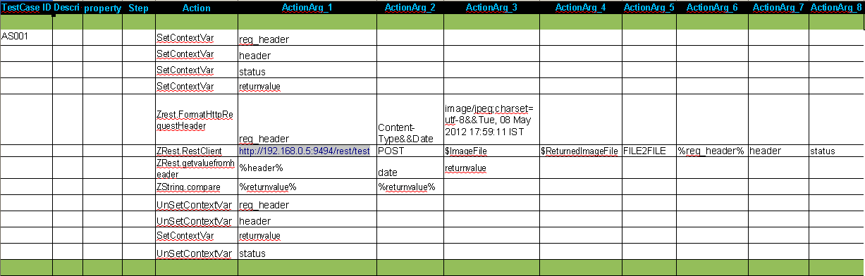

The following are the parameters for PUT method:

Parameter Name | Purpose | Type | Valid Values | Direction | Optional? | Default Value
url | First Argument which must be a valid url | Scalar | any string | Input | Required | none
method | Should be PUT | Scalar | any string | Input | Required | none
requestbody | Post data to send to be sent to the webservice | Scalar | any string | Input | Optional | none
Response | Response data from the server to be returned in it(ContextVariable) | Scalar |  | Output | Required | none
mode | Specifies whether the input and output variables will be context variables or files | Scalar | CV2CV,  CV2FILE,FILE2CV,FILE2FILE | Input | Required | none
RequestHeader | Header value to be set | Scalar | Double ampersand (&&)  separated key value pairs or default | Input | Required | default
ResponseHeader | Context variable name  to store the header sent  by the server | Scalar | any string | Output | Optional | none
Status | Context variable name  to store the response  code of the server | Scalar | any string | Output | Optional | none

Example:

In the following testcase we are setting the Request Header and reading the response header and
sending an image to the server and receiving the same image from the server.

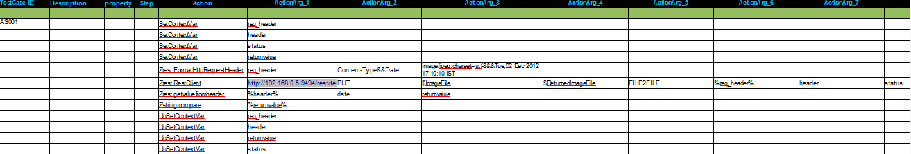

The following are the parameters for HEAD method:

Parameter Name | Purpose | Type | Valid Values | Direction | Optional? | Default Value
url | First Argument which must be a valid url | Scalar | any string | Input | Required | none
method | Should be HEAD | Scalar | any string | Input | Required | none
RequestHeader | Header value to be set | Scalar | Double ampersand (&&)  separated key value pairs or default | Input | Required | default
ResponseHeader | Context variable name  to store the header sent  by the server | Scalar | any string | Output | Required | none
Status | Context variable name  to store the response  code of the server | Scalar | any string | Output | Optional | none

Example
RestClient("url","HEAD",Content-Type=text/html;charset=utf-8&&Connection=Keep-Alive, response_header,status)

6.2 FormatHTTPRequestHeader

Description
It takes a context variable, keylist and valuelist for formatting it as an ampersand(&) key-value
pair

Example
FormatHttpRequestHeader("context variable",keylist,valuelist)

Return Codes:
Success: Returns the key=value pair in a context variable
Failure: AtomExecutionException by Zuoz.

To see the list of HTTP header fields, click here.

meter

Parameter Name | Purpose | Type | Valid Values | Direction | Optional?
context  variable | First Argument which is  the return value of the  formatted output of this  atom(ContextVariable) | Scalar | any string | Input | Required
Keylist | List of Ampersand (&) separated Header field names | Scalar | any string | Input | Required
Valuelist | List of Ampersand (&) separated header field values | Scalar | any string | Input | Required
Valid
Example:
In the following example we have set two fields Content-Type and From in the HTTP header.
Also we have shown how to use the GET method and storing the response in a context variable.

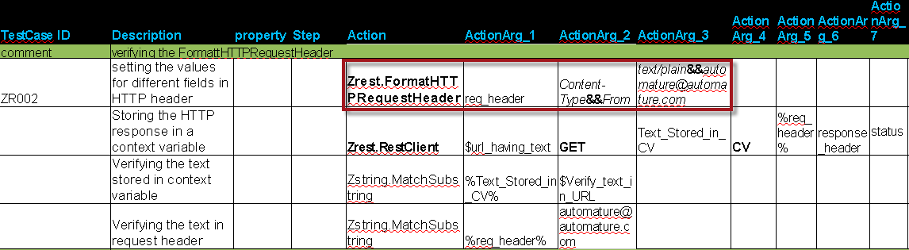

Here is the snapshot of fiddler tool when the above test case was run

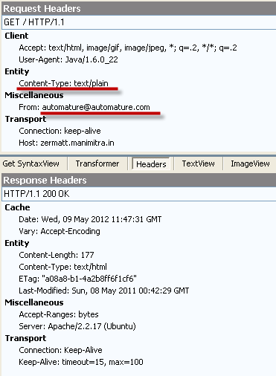

6.3 GetValueFromHeader

Description

Retrieves the value of a header field by its key name

Example

GetValueFromHeader(null=HTTP/1.1 200 OK&&Content-
Type=text/html;charset=utf-8&&Server=WEBrick/1.3.1 (Ruby/1.9.2/2011-02-
18)&&Date=Mon, 07 May 2012 13:23:11 GMT&&Content-
Length=28521&&Connection=Keep-Alive, date, returnvalue)
arameter
Parameter Name | Purpose | Type | Valid Values | Direction | Optional?
HTTPheaderValue | The Value of the Header | Scalar | any string | Input | Required
HeaderFieldName | Name of the header field  whose value is to be  retrieved | Scalar | any string | Input | Required
ReturnValue | Name of a context  variable to store the  value of a header field  given its key | Scalar | any string | Input | Required

Example:
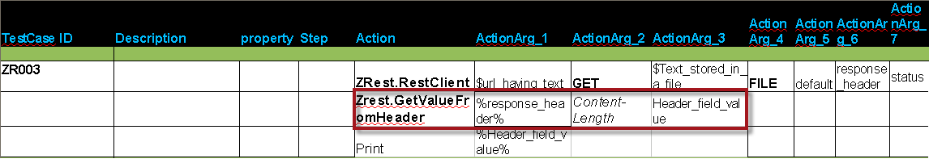

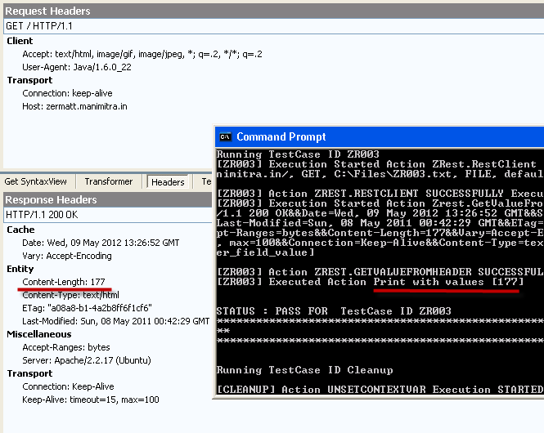

XML Atoms

All the Atoms in this section are available in Zxml In process package file. Hence all the Atoms are referenced in CHUR spreadsheet as Zxml.<atom-name>. The following atoms can read/parse any xml content.

<root>
<languages>
<language name="Ruby">
<extension>rb</extension>
<interpreter>ruby</interpreter>
<path>C:\Ruby\bin</path>
</language>
</languages>
<inprocesspackages>
<inprocesspackage name="ZBrowser">
<file-path>C:\Program Files\Automature\ZUOZ\Inprocess</file-path>
<jar-package>com.automature.zuoz.inprocess.zbrowser</jar-package>
<class-name>BrowserOperation</class-name>
</inprocesspackage>
<inprocesspackage name="ZString">
<file-path>C:\Program Files\Automature\ZUOZ\Inprocess</file-path>
<language>Java</language>
<interpreter>java.exe</interpreter>
</inprocesspackage>
</inprocesspackages>
<configurations>
<mvm-configuration jvm-max-memorysize="853">4000</mvm-configuration>
<mvm-configuration jvm-max-memorysize="455">3000</mvm-configuration>
</configurations>
</root>

7.1 GetTagValues

Description
It gets all the tag values of a xml content and returns the comma separated values in a context variable.

Example

Zxml.GetTagValues(xml,keytagname,returntagvalues)

Return Codes:
Success: Response stored in context variable here 'returntagvalues'
Failure: AtomExecutionException message logged in log error file and message shown in console.

Parameter Name | Purpose | Type | Valid Values | Direction | Optional?
xml | First Argument must contain a valid xml content. It must be passed by reference i.e. as a Context Variable name. | Scalar | any valid xml structure | Input | Required
keytagname | Specify the path to the desired node, separated by # | Scalar | any string | Input | Required
returntagvalues | Returns comma separated values of the tags inside the key tag name. | Scalar | any string | Input | Required

Example:
In the following example we read the file content which is as stated in the beginning of this chapter.
The key_tag_path is root#languages#language.
The atom returns the tag values as rb,ruby,C:\Ruby\bin

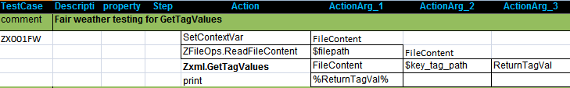

7.2 GetAttributeValues

Description
It gets the attribute values of a xml content while passing the attribute names list and returns the comma separated values in a context variable.

Example

Zxml.GetAttributeValues(xml,keytagname,attributename,returnattributevalues)

Return Codes:
Success: Response stored in context variable here 'returnattributevalues'
Failure: AtomExecutionException message logged in log error file and message shown in console.

Parameter Name | Purpose | Type | Valid Values | Direction | Optional?
xml | First Argument must contain a valid xml content. It must be passed by reference i.e. as a Context Variable name. | Scalar | any valid xml structure | Input | Required
keytagname | Specify the path to the desired node, separated by # | Scalar | any string | Input | Required
attributename | Name of the attributes to be read. | Scalar | any string | Input | Required
returnattributevalues | Returns comma separated attribute values of the tags inside the key tag name. | Scalar | any string | Input | Required

Example:
In the following example we read the file content which is as stated in the beginning of this chapter.
The key_second_tag_path is root#inprocesspackages
The atom will return attribute values Zbrowser,ZString

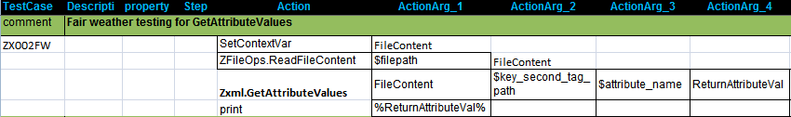

7.3 GetAttributeAndTagValues

Description
Its gets the attributes and tag values of a xml content, while passing keytagname and returns the values in a comma separated list, in a context variable.

Example

Zxml.GetAttributeAndTagValues(xml,keytagname,attributename,returnattributevalues,returntagvalues)

Return Codes:
Success: Response stored in context variable here 'returnattributevalues' and 'returntagvalues'
Failure: AtomExecutionException message logged in log error file and message shown in console.
Parameter Name | Purpose | Type | Valid Values | Direction | Optional?
xml | First Argument must contain a valid xml content. It must be passed by reference i.e. as a Context Variable name. | Scalar | any valid xml structure | Input | Required
keytagname | Specify the path to the desired node, separated by # | Scalar | any string | Input | Required
attributename | Name of the attributes to be read. | Scalar | any string | Input | Required
returnattributevalues | Returns comma separated attributes of the tags inside the tag name. | Scalar | any string | Output | Required
returntagvalues | Returns comma separated values of the tags inside the key tag name. | Scalar | any string | Output | Required

Example:
In the following example we read the file content which is as stated in the beginning of this chapter.
The key_third_tag_path is root#configurations and the second_attribute_name is jvm.-max-memorysize

The atom returns the attribute values as 853,455 and returns tag values as 4000,3000.
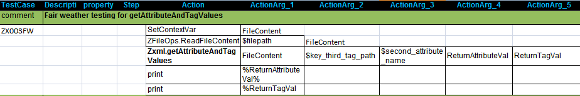

7.4 GetTagValueByIndex

Description
Its gets the tag values of a xml content, while passing keytagname and keyindex, it returns the values in a comma separated list, in a context variable.

Example

Zxml.GetTagValueIndex(xml,keytagname,keyindex,returntagvalue)

Return Codes:
Success: Response stored in context variable here 'returntagvalue'
Failure: AtomExecutionException message logged in log error file and message shown in console.

Parameter Name | Purpose | Type | Valid Values | Direction | Optional?
xml | First Argument must contain a valid xml content. It must be passed by reference i.e. as a Context Variable name. | Scalar | any valid xml structure | Input | Required
keytagname | Specify the path to the desired node, separated by # | Scalar | any string | Input | Required
keyindex | Index of the tag. | Scalar | any string | Input | Required
returntagvalue | Returns comma separated values of the tags inside the key tag name. | Scalar | any string | output | Required

Example:
In the following example we read the file content which is as stated in the beginning of this chapter.
The key_second_tag_path is root#inprocesspackages and the keyindex is 2.
The atom returns the tag value C:\Program Files\Automature\ZUOZ\Inprocess,Java, java.exe

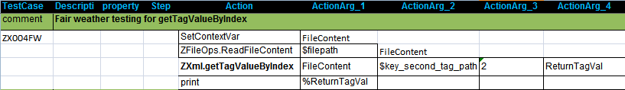

7.5 GetTagNames

Description
Returns the tag names in a particular tag of a xml content as a comma separated list in a context variable.

Example

Syntax:
Zxml.GetTagNames(xml_content,tagname_path,returntagnames)

Example:
Zxml.GetTagNames(xml_content, root#languages#language, returntagnames)

The contextvariablename will contain the following string - extension,interpreter,path

Zxml.GetTagNames(xml_content, root#inprocesspackages#inprocesspackage[2], returntagnames)

The contextvariablename will contain the following string - file-path, language,interpreter

Return Codes:
Success: Response stored in context variable here 'returntagnames'
Failure: AtomExecutionException message logged in log error file and message shown in console.

Parameter Name | Purpose | Type | Valid Values | Direction | Optional?
xml_content | First Argument must contain a valid xml content. It must be passed by reference i.e. as a Context Variable name. | Scalar | any valid xml structure | Input | Required
tagname_path | Specify the path to the desired node, separated by # | Scalar | any string | Input | Required
returntagnames | Returns comma separated names of the tags inside the key tag name. | Scalar | any string | Input | Required

Example:
In the following example we read the file content which is as stated in the beginning of this chapter. The key_fourth_tag_path is root#inprocesspackages#inprocesspackage[2]
The atom returns the tag names as file-path,language,interpreter.

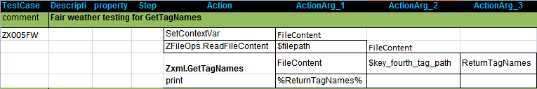

7.6 ConvertXMLtoJSON

Description

Converts a simple XML to JSON text format and returns it to a context variable

Example

Syntax:
Zxml.ConvertXMLtoJSON(xml, json)

Following is the example of a simple XML. The JSON text will be stored in the context variable json.

XML text | JSON text
<root>  <languages>  <language name="Ruby">  <extension>rb</extension>  <interpreter>ruby</interpreter>  <path>C:\Ruby\bin</path>  </language>  </languages>  </root> | {  "root": {  "languages": {  "language": {  "-name": "Ruby",  "extension": "rb",  "interpreter": "ruby",  "path": "C:\\Ruby\\bin"  }  }  }  }

Return Codes:

Success: Response stored in 'context variable json'.
Failure: AtomExecutionException message logged in log error file and the error message shown in console.

Parameter Name | Purpose | Type | Valid Values | Direction | Optional?
xml | First Argument must contain a valid xml content. It must be passed by reference i.e. as a Context Variable name. | Scalar | any string | Input | Required
kson | Returns the XML content in that context variable | Scalar | Any string | Output | Required

Following is the simple testcase to convert an xml text to json text.

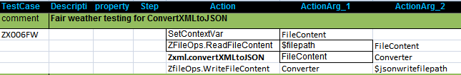

7.7 AddTag

Description
Appends a XML tag to the XML text and returns the modified XML text to a context variable.

Example
Syntax:
Zxml.AddTag(xml, keyTagName, tag_name, tag_value, modified_xml)

Example 1:

Zxml.AddTag (xml, root#languages#language,version,1.6,modified_xml)

The modified_xml will contain the string as shown below:

XML text | Modified XML text
<root>  <languages>  <language name="Ruby">  <extension>rb</extension>  <interpreter>ruby</interpreter>  <path>C:\Ruby\bin</path>  </language>  </languages>  </root> | <root>  <languages>  <language name="Ruby">  <extension>rb</extension>  <interpreter>ruby</interpreter>  <path>C:\Ruby\bin</path>  <version>1.6</version>  </language>  </languages>  </root>

Parameter Name | Purpose | Type | Valid Values | Direction | Optional?
xml | First Argument must contain a valid xml content. It must be passed by reference i.e. as a Context Variable name. | Scalar | any valid xml structure | Input | Required
keytagname | Specify the path to the desired node, separated by # | Scalar | any string | Input | Required
tag_name | Name of the tag to be added | Scalar | any string | Input | Required
tag_value | Value of the tag to be added | Scalar | any string | Input | Required
modified_xml | Returns the XML content in that context variable | Scalar | Any string | Output | Required

Example:
In the following example we read the file content which is as stated in the beginning of this chapter. The key_tag_path is root#languages#language. The add_tag name is version and the add_tag_value is 1.6.
The modified xml is stored in the ReturnTagVal. It contains an additional tag <version>1.6</version>

7.8 AddAttribute

Description
Adds a XML tag attribute to a particular tag in a XML and returns the modified XML text to a context variable.

Example
Syntax:
Zxml.AddAttribute(xmlcontent, keyTagName, attributename, attributevalue, modified_xml)

Example 1:
Zxml.AddAttribute (xmlcontent,root#languages#language#version,major,1.6,modified_xml)

The modified_xml will contain the string as shown below:

XML text | Modified XML text
<root>  <languages>  <language name="Java">  <version>  <extension>rb</extension>  <interpreter>ruby</interpreter>  <path>C:\Ruby\bin</path>  <version>  </language>  </languages>  </root> | <root>  <languages>  <language name="Java">  <version major =”1.6”>  <extension>rb</extension>  <interpreter>ruby</interpreter>  <path>C:\Ruby\bin</path>  </version>  </language>  </languages>  </root>

Parameter Name | Purpose | Type | Valid Values | Direction | Optional?
xmlcontent | First Argument must contain a valid xml content. It must be passed by reference i.e. as a Context Variable name. | Scalar | any valid xml structure | Input | Required
keytagname | Specify the path to the desired node, separated by # | Scalar | any string | Input | Required
attributename | Name of the attribute to be added | Scalar | any string | Input | Required
attributevalues | Value of the attribute to be added | Scalar | any string | Input | Required
modified_xml | Returns the XML content in that context variable | Scalar | Any string | Output | Required

Example:
In the following example we read the file content which is as stated in the beginning of this chapter. The key_tag_path is root#languages. The add_attrib_name is version and the add_attrib_value is 1.8.7.
The ReturnTagVal will contain the tag <language name="Ruby" version="1.8.7"> which was previously <language name="Ruby">

7.9 ReadXMLNode

Description
Returns a XML node in a context variable as a string.

Example

Syntax:
Zxml.readXMLNode(xmlcontent, keyTagName, return_xml_node)

Example:
Zxml.readXMLNode(xml_content, root#languages#language, return_xml_node)

The return_xml_node will contain the following string - <extension>rb</extension>
<interpreter>ruby</interpreter>
<path>C:\Ruby\bin</path>

Return Codes:
Success: Response stored in context variable here 'returntagnames'
Failure: AtomExecutionException message logged in log error file and message shown in console.

Parameter Name | Purpose | Type | Valid Values | Direction | Optional?
xmlcontent | First Argument must contain a valid xml content. It must be passed by reference i.e. as a Context Variable name. | Scalar | any valid xml structure | Input | Required
keytagname | Specify the path to the desired node, separated by # | Scalar | any string | Input | Required
return_xml_node | Returns the XML content in that context variable | Scalar | Any string | Output | Required

Example:
In the following example we read the file content which is as stated in the beginning of this chapter. The key_tag_path is root#languages#language.
The ReturnTagVal will contain the tag
<extension>rb</extension>
<interpreter>ruby</interpreter>
<path>C:\Ruby\bin</path>

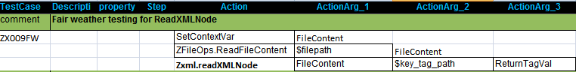

7.10 GetTagValuesByAttribute

Description
Its gets the tag values of a xml content by specifying the attribute name and value, returns the values as a comma separated list, in a context variable.

Example

Syntax:
Zxml.GetTagValuesByAttribute(xmlcontent, keyTagName, key_attribute_name, key_attribute_value,return_tag_values)

Example:
Zxml.GetTagValuesByAttribute(xmlcontent, root#inprocesspackages#inprocesspackage,name,ZBrowser,returnContextVar)

The Context variable return_tag_values will contain the following string:
C:\Program Files\Automature\ZUOZ\Inprocess, com.automature.zuoz.inprocess.zbrowser, BrowserOperation

Return Codes:
Success: Response stored in context variable here 'returnattributevalues' and 'returntagvalues'
Failure: AtomExecutionException message logged in log error file and message shown in console.
Parameter Name | Purpose | Type | Valid Values | Direction | Optional?
xmlcontent | First Argument must contain a valid xml content. It must be passed by reference i.e. as a Context Variable name. | Scalar | any valid xml structure | Input | Required
keytagname | Specify the tag attribute node, separated by # | Scalar | any string | Input | Required
key_attribute_name | Name of the attribute | Scalar | any string | Input | Required
key_attribute_value | Value of the attribute | Scalar | any string | Output | Required
return_tag_values | Returns the tag values as a comma separated list in that context variable | Scalar | Any string | Output | Required

Example:
In the following example we read the file content which is as stated in the beginning of this chapter. The key_second_tag_path is root#inprocesspackages .
The key_attrib_name is name and the key_attrib_value is ZString.
The ReturnTagVal will contain the tag values as a comma separated list
C:\Program Files\Automature\ZUOZ\Inprocess,Java,java.exe

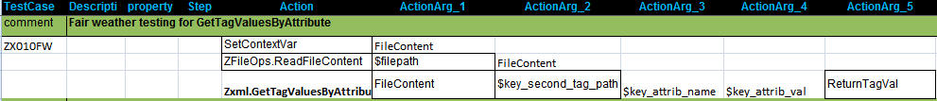

File Operation Atoms

All the Atoms in this section are available in ZFileOps In process package file. Hence all the Atoms are referenced in CHUR spreadsheet as ZFileOps.<atom-name>. The following atoms can use the basic functionality of any context variable, like setcontextvar, appendtocontextvar etc.
More than that there is another new atom which can be used to store a file content inside a context variable.

8.1 ReadFileContent

Description
Its reads the content of the file from a given file path and stores/saves the content in a context variable.

Example

ReadFileContent(filepath,filecontent)

Return Codes:
Success: Response stored in context variable 'filecontent'.
Failure: AtomExecutionException message logged in log error file and the error message shown in console.

Parameter Name | Purpose | Type | Valid Values | Direction | Optional?
filepath | First Argument which must be a valid fully qualified path or a relative path. It can be passed as a context variable. | Scalar | any valid file path | Input | Required
filecontent | File content stored(not More than 1 mb). | Scalar | any string | Output | Required

Example:

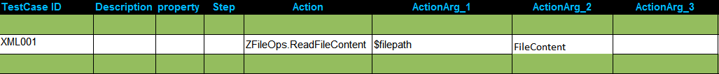

8.2 WriteFileContent

Description
It stores the content in the context variable to a file in a given file path. If the file does not exist then it creates a new file, else it over-writes the file with the content.

Example

WriteFileContent(filecontent, filepath)

Return Codes:
Success: Response stored in the given file.
Failure: AtomExecutionException message logged in log error file and the error message shown in console.

Parameter Name | Purpose | Type | Valid Values | Direction | Optional?
filecontent | Content stored(not More than 1 mb) in the context variable. | Scalar | any string | Input | Required
filepath | Second Argument which must be a valid fully qualified path or a relative path. It can be passed as a context variable. | Scalar | any valid file path | Input | Required

8.3 GetFileSize

Description
Returns the file size in a context variable in bytes.

Example

GetFileSize(filepath, filesize)

Return Codes:
Success: Response stored in 'filesize'.
Failure: AtomExecutionException message logged in log error file and the error message shown in console.

Parameter Name | Purpose | Type | Valid Values | Direction | Optional?
filepath | Must be a valid fully qualified path or a relative path. | Scalar | any valid file path | Input | Required
filesize | Context variable name passed by reference to store the file size | Scalar | Any string | Output | Required

8.4 ComputeChecksum

Description
It computes the checksum of a file in given format/algorithm.

Example

computeChecksum(filepath,data_integrity_verify_algorithm, get_checksum)

Return Codes:
Success: Response stored in context variable 'get_checksum'.
Failure: AtomExecutionException message logged in log error file and the error message shown in console.

Parameter Name | Purpose | Type | Valid Values | Direction | Optional?
filepath | Must be a valid fully qualified path or a relative path. | Scalar | any valid file path | Input | Required
data_integrity_verify_algorithm | A secure hash algorithm to compute the checksum. | Scalar | MD5 or SHA1 | Input | Required
get_checksum | Context variable name passed by reference to store the file checksum. | Scalar | Any string | Output | Required

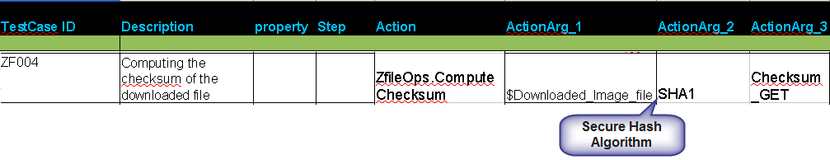

JSON Atoms

All the Atoms in this section are available in ZJSON In process package file. These atoms are referenced in CHUR spreadsheet as Zjson.<atom-name> because of the mapping done in ZugINI.xml.The following atoms can be used to read, parse or add any JSON content.

The following is an example of a JSON text:

{
"glossary": {
"title": "example glossary",
"GlossDiv": {
"title": "S",
"GlossList": {
"GlossEntry": {
"ID": "SGML",
"SortAs": "SGML",
"GlossTerm": "Standard Generalized Markup Language",
"Acronym": "SGML",
"Abbrev": "ISO 8879:1986",
"GlossDef": {
"para": "A meta-markup language, used to create markup languages such as DocBook.",
"GlossSeeAlso": ["GML", "XML"]
},
"GlossSee": "markup"
}
}
}
}
}

9.1 GetObject

Description

Returns a JSON object as a string to the context variable.

Example

Syntax:
ZJSON.GetObject(JSON_text, object_tree, object_list)

Example:
ZJSON.GetObject(JSON_text, glossary#GlossDiv#GlossList#GlossEntry, object_list)

The context variable object_list will contain the string
“ ID, SortAs, GlossTerm, Acronym, Abbrev, GlossDef, GlossSee “

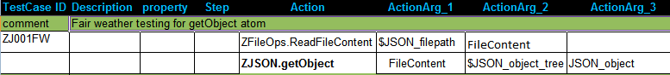

Return Codes:
Success: Response stored in 'contextvariablename'.
Failure: AtomExecutionException message logged in log error file and the error message shown in console.
Parameter Name | Purpose | Type | Valid Values | Direction | Optional?
JSON_text | Must be a valid JSON text (which should be passed as reference) i.e. name of the Context Variable where JSON text is stored. | Scalar | any string | Input | Required
object_tree | Specify the path to the desired object, separated by # | Scalar | any string | Input | Required
object_list | Returns all the keys as a comma separated list in that object | Scalar | Any string | Output | Required

9.2 GetObjectKeys

Description
Returns a comma separated list of keys within a JSON object to the context variable.

Example
Syntax:
ZJSON.GetObjectKeys(JSON_text, object_tree, object_keys)
Example:

ZJSON.GetObjectKeys(JSON_text, glossary#GlossDiv#GlossList#GlossEntry#GlossDef, object_keys)

The object_keys will contain the string “ para,GlossSeeAlso “

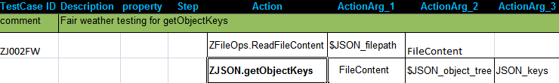

Return Codes:

Success: Response stored in 'object_keys'.
Failure: AtomExecutionException message logged in log error file and the error message shown in console.

Parameter Name | Purpose | Type | Valid Values | Direction | Optional?
JSON_text | Must be a valid JSON text (which should be passed as reference) i.e. name of the Context Variable where JSON text is stored. | Scalar | any string | Input | Required
object_tree | Specify the path to the desired object, separated by # | Scalar | any string | Input | Required
object_keys | Returns the value of the desired object in the context variable | Scalar | Any string | Output | Required

9.3 GetObjectValueByKey

Description
Returns the value of a particular key within a JSON object to the context variable.

Example
Syntax:
ZJSON.GetObjectValueByKey(JSON_text, object_tree, key_name, key_value)

Example 1:

ZJSON.GetObjectValueByKey (JSON_text, glossary#GlossDiv#GlossList#GlossEntry, SortAs ,key_value)

The context variable key_value will contain the string “ ISO 8879:1986 “.

Example 2:

ZJSON.GetObjectValueByKey (JSON_text, glossary#GlossDiv#GlossList#GlossEntry#GlossDef, GlossSeeAlso, key_value)

The context variable key_value will contain the string “ ["GML", "XML"] “

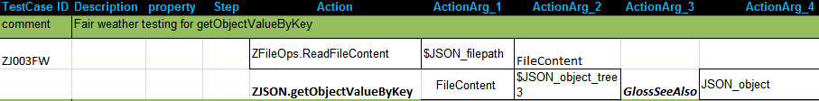

Return Codes:
Success: Response stored in 'key_value'.
Failure: AtomExecutionException message logged in log error file and the error message shown in console.

Parameter Name | Purpose | Type | Valid Values | Direction | Optional?
JSON_text | Must be a valid JSON text (which should be passed as reference) i.e. name of the Context Variable where JSON text is stored. | Scalar | any string | Input | Required
object_tree | Specify the path to the desired object, separated by # | Scalar | any string | Input | Required
key_name | Name of a key within the object | Scalar | any string | Input | Required
key_value | Returns the value of the desired key in the context variable | Scalar | Any string | Output | Required

9.4 GetObjectKeyValueByIndex

Description

Returns the value of a particular key within a JSON object to the context variable for a given key ndex.

Example

Syntax:
ZJSON.GetObjectKeyValueByIndex(JSON_text, object_tree, key_index, key_value)

Example 1:

ZJSON.GetObjectKeyValueByIndex (JSON_text, glossary#GlossDiv#GlossList#GlossEntry, 5 ,key_value)

The key_value will contain the string “ SGML “.

Example 2:

ZJSON.GetObjectValueByKey (JSON_text, glossary#GlossDiv#GlossList#GlossEntry#GlossDef, 1, key_value)

The context variable key_value will contain the string "A meta-markup language, used to create markup languages such as DocBook."

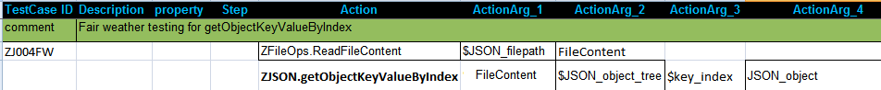

Return Codes:
Success: Response stored in 'key_value'.
Failure: AtomExecutionException message logged in log error file and the error message shown in console.

Parameter Name | Purpose | Type | Valid Values | Direction | Optional?
JSON_text | Must be a valid JSON text (which should be passed as reference) i.e. name of the Context Variable where JSON text is stored. | Scalar | any string | Input | Required
object_tree | Specify the path to the desired object, separated by # | Scalar | any string | Input | Required
key_index | Index of a key within the object | Scalar | any string | Input | Required
key_value | Returns the value of the desired key in the context variable | Scalar | Any string | Output | Required

9.5 AddObject

Description
Appends a JSON object to the JSON text and returns the modified JSON text to a context variable.

Example
Syntax:
ZJSON.AddObject(JSON_text, object_tree, key_name, key_value, modified_json_text)

Example 1:

ZJSON.AddObject (JSON_text, glossary#GlossDiv#GlossList#GlossEntry#GlossDef,”ABC”, "[“A”,”B”,”C”,”D”]”, modified_json_text)

The context variable modified_json_text will contain the string

Input JSON text | Output JSON text
{  "glossary": {  "title": "example glossary",  "GlossDiv": {  "title": "S",  "GlossList": {  "GlossEntry": {  "ID": "SGML",  "SortAs": "SGML",  "GlossTerm": "Standard Generalized Markup Language",  "Acronym": "SGML",  "Abbrev": "ISO 8879:1986",  "GlossDef": {  "para": "A meta-markup language, used to create markup languages such as DocBook.",  "GlossSeeAlso": ["GML", "XML"]  },  "GlossSee": "markup"  }  }  }  }  } | {  "glossary": {  "title": "example glossary",  "GlossDiv": {  "title": "S",  "GlossList": {  "GlossEntry": {  "ID": "SGML",  "SortAs": "SGML",  "GlossTerm": "Standard Generalized Markup Language",  "Acronym": "SGML",  "Abbrev": "ISO 8879:1986",  "GlossDef": {  "para": "A meta-markup language, used to create markup languages such as DocBook.",  "GlossSeeAlso": ["GML", "XML"],  “ABC”: [“A”,”B”,”C”,”D”]  },  "GlossSee": "markup",  "XXX": "YYY"  }  }  }  }  }
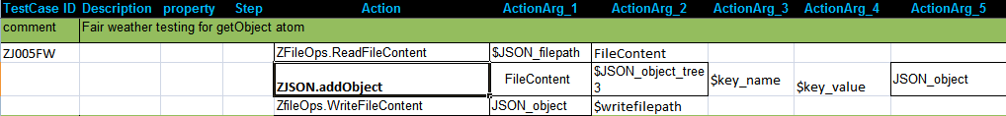

Return Codes:
Success: Response stored in 'modified_json_text'.
Failure: AtomExecutionException message logged in log error file and the error message shown in console.

Parameter Name | Purpose | Type | Valid Values | Direction | Optional?
JSON_text | Must be a valid JSON text (which should be passed as reference) i.e. name of the Context Variable where JSON text is stored. | Scalar | any string | Input | Required
object_tree | Specify the path to the desired object, separated by # | Scalar | any string | Input | Required
key_name | Name of a key to be inserted. | Scalar | any string | Input | Required
key_value | Value of the above key to be inserted. | Scalar | any string | Input | Required
modified_json_text | Returns all the keys as a comma separated list in that object | Scalar | Any string | Output | Required

9.6 ConvertJSONtoXML

Description

Converts a simple JSON text to XML format and returns it to a context variable

Example

Syntax:
ZJSON.ConvertJSONtoXML(JSON_text, converted_to_xml)

Following is the example of a simple JSON text. The XML text will be stored in the context variable converted_to_xml.

JSON text | XML text
{  "note": {  "to": "Tove",  "from": "Jani",  "heading": "Reminder",  "body": "Don't forget me this weekend!"  }  } | <note>  <to>Tove</to>  <from>Jani</from>  <heading>Reminder</heading>  <body>Don't forget me this weekend!</body>  </note>

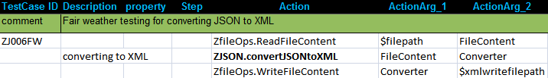

Return Codes:

Success: Response stored in 'converted_to_xml'.
Failure: AtomExecutionException message logged in log error file and the error message shown in console.

Parameter Name | Purpose | Type | Valid Values | Direction | Optional?
JSON_text | Must be a valid JSON text (which should be passed as reference) i.e. name of the Context Variable where JSON text is stored. | Scalar | any string | Input | Required
converted_to_xml | Returns the XML content in that context variable | Scalar | Any string | Output | Required

9.7 Zjson.MatchElementsbyIndex

Description

It matches the elements of an object of a JSON array using index of that object.

Example
The following is an example of a JSON text:
{
"name": "John Smith",
"age": 32,
"employed": true,
"address": {
"street": "701 First Ave.",
"city": "Sunnyvale, CA 95125",
"country": "United States"
},
"children": [
{
"name": "Richard",
"age": 7
},
{
"name": "Susan",
"age": 4
},
{
"name": "James",
"age": 3
}
]
}
Syntax:

Zjson.matchElementsByIndex (JSON_text, object_tree, key_value-elements, object_Index )

Example 1:
Zjson.matchElementsByIndex( JSON_text,children,"name":"Richard","age":7, 1)

Return Codes:

Success: Return 0
Failure: AtomExecutionException message logged in log error file and the error message shown in console.

Parameter Name | Purpose | Type | Valid Values | Direction | Optional?
JSON_text | Must be a valid JSON text (which should be passed as reference) i.e. name of the Context Variable where JSON text is stored. | Scalar | any string | Input | Required
object_tree | Specify the name of the json array | Scalar | any string | Input | Required
key_value-elements | List of elements to be match. Should be pass by context-Variables | Scalar | any string | Input | Required
object_Index | Array Index number in which key_value-elements is present. | Scalar | any string | Input | Required

9.8 Zjson.MatchForElements

Description

It matches the elements of an object in a particular Json text.

Example
The following is an example of a JSON text:
{
"medications": {
"aceInhibitors": {
"name": "lisinopril",
"strength": "10 mg Tab",
"dose": "1 tab",
"route": "PO",
"sig": "daily",
"pillCount": "#90",
"refills": "Refill 3"
},
"antianginal": {
"name": "nitroglycerin",
"strength": "0.4 mg Sublingual Tab",
"dose": "1 tab",
"route": "SL",
"sig": "q15min PRN",
"pillCount": "#30",
"refills": "Refill 1"
},
"anticoagulants": {
"name": "warfarin sodium",
"strength": "3 mg Tab",
"dose": "1 tab",
"route": "PO",
"sig": "daily",
"pillCount": "#90",
"refills": "Refill 3"
},
"betaBlocker": {
"name": "metoprolol tartrate",
"strength": "25 mg Tab",
"dose": "1 tab",
"route": "PO",
"sig": "daily",
"pillCount": "#90",
"refills": "Refill 3"
},
"diuretic": {
"name": "furosemide",
"strength": "40 mg Tab",
"dose": "1 tab",
"route": "PO",
"sig": "daily",
"pillCount": "#90",
"refills": "Refill 3"
},
"mineral": {
"name": "potassium chloride ER",
"strength": "10 mEq Tab",
"dose": "1 tab",
"route": "PO",
"sig": "daily",
"pillCount": "#90",
"refills": "Refill 3"
}
},
"labs": [
{
"name": "Arterial Blood Gas",
"time": "Today",
"location": "Main Hospital Lab"
},
{
"name": "BMP",
"time": "Today",
"location": "Primary Care Clinic"
},
{
"name": "BNP",
"time": "3 Weeks",
"location": "Primary Care Clinic"
},
{
"name": "BUN",
"time": "1 Year",
"location": "Primary Care Clinic"
},
{
"name": "Cardiac Enzymes",
"time": "Today",
"location": "Primary Care Clinic"
},
{
"name": "CBC",
"time": "1 Year",
"location": "Primary Care Clinic"
},
{
"name": "Creatinine",
"time": "1 Year",
"location": "Main Hospital Lab"
},
{
"name": "Electrolyte Panel",
"time": "1 Year",
"location": "Primary Care Clinic"
},
{
"name": "Glucose",
"time": "1 Year",
"location": "Main Hospital Lab"
},
{
"name": "PT/INR",
"time": "3 Weeks",
"location": "Primary Care Clinic"
},
{
"name": "PTT",
"time": "3 Weeks",
"location": "Coumadin Clinic"
},
{
"name": "TSH",
"time": "1 Year",
"location": "Primary Care Clinic"
}
],
"imaging": [
{
"name": "Chest X-Ray",
"time": "Today",
"location": "Main Hospital Radiology"
},
{
"name": "Chest X-Ray",
"time": "Today",
"location": "Main Hospital Radiology"
},
{
"name": "Chest X-Ray",
"time": "Today",
"location": "Main Hospital Radiology"
}
]
}

Syntax:

Zjson.matchForElements(JSON_text,object_tree,key_value-elements,key_value)

Example 1:

Zjson.matchForElements( JSON_text,medications#anticoagulants, "name":"warfarin sodium","sig":"daily", returnval)

Return Codes:

Success: Return 0
Failure: AtomExecutionException message logged in log error file and the error message shown in console.

Parameter Name | Purpose | Type | Valid Values | Direction | Optional?
JSON_text | Must be a valid JSON text (which should be passed as reference) i.e. name of the Context Variable where JSON text is stored. | Scalar | any string | Input | Required
object_tree | Specify the path to the desired object, separated by # | Scalar | any string | Input | Required
key_value-elements | List of elements to be match. Should be pass by context-Variables. | Scalar | any string | Input | Required
key_value | Returns the value of the desired key in the context variable. | Scalar | any string | Input | Required

Database Atoms

All the Atoms in this section are available in ZDB In process package file. These atoms are referenced in CHUR spreadsheet as Zdb.<atom-name> because of the mapping done in ZugINI.xml.
The following atoms can be used to connect as well as disconnect and also execute any DML queries and retrieve the result.

10.1 Connect

Description

Connects to a specific database, validates user credentials, and returns a handle for the connection in a context variable. This handle can subsequently be used to query the database, or execute other SQL statements against the database. Note that the connection is not thread-safe, i.e. not more than a single database operation can be concurrently executed using the same database handle.

Example

Syntax:
ZDB.Connect(Username, Password, Database_URL, Database_type, Connection)

Example:
ZDB.Connect(JohnSmith, secret, localhost/Framework, MySQL, Connect1)

Exception:

Failure: AtomExecutionException message logged in log error file and the error message shown in console.

Parameter Name | Purpose | Type | Valid Values | Direction | Optional?
Username | Username of the database | Scalar | any string | Input | Required
Password | Password of the database | Scalar | any string | Input | Required
Database_URL | States the Database connection URL.  Example-<Mysqlhostmachine>/<DatabaseName> | Scalar | A string representing the IP address, a hostname, or the domain qualified hostname of the database machine, plus the name of the database | Input | Required
Database_type | Specifies Database Server Name. | Scalar | Any string | Input | Required
Connection | Returns the connection in a context variable | Scalar | Any string | Output | Required

Example:

10.2 Disconnect

Description
Disconnects or destroys the database connection.

Example
Syntax:
ZDB.Disconnect(ConnectionValue)

Example:
ZDB.Disconnect(%Connect1%)

Exception:

Failure: AtomExecutionException message logged in log error file and the error message shown in console.

Parameter Name | Purpose | Type | Valid Values | Direction | Optional?
ConnectionValue | The handle of the database connection which was returned in a context variable, from a previous call to Connect. | Scalar | any string | Input | Required

Example:

10.3 Execute

Description

Executes a DML statement. There are three types of DML queries that this atom can execute - INSERT, UPDATE and DELETE.

Zuoz Context-Variables for Execute atom
Zuoz defines and maintains some automatic global context variables for the Execute Atom. These variables may be used by the test case designer for developing test cases.

Name | Purpose | Comments | Output
ZUOZ_ZDB_ROWCOUNT | Returns the number of rows returned. | If there are no rows affected, then it returns zero. | A numeric value.

Example

Syntax:
ZDB.Execute(Connection_value,Execute_query)

Example:
ZDB.Execute(%Connect1%,$Execute_query)

Here the macro $execute_query can have any DML query.
$execute_query=INSERT into role (role_name, description) VALUES ('Zug Client', 'for testing')

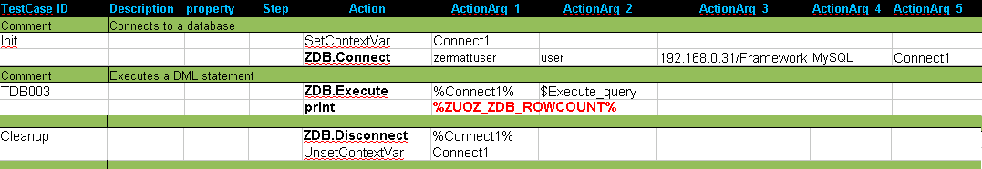

Exception:

Failure: AtomExecutionException message logged in log error file and the error message shown in console.

Parameter Name | Purpose | Type | Valid Values | Direction | Optional?
Connection_value | The handle of the database connection which was returned in a context variable, from a previous call to Connect. | Scalar | any string | Input | Required
Execute_query | Any DML query | Scalar | MYSQL or MS-SQL | Input | Required

10.4 Query

Description

Executes a DQL statement.

Zuoz Context-Variables for Query atom
Zuoz defines and maintains some automatic global context variables for the Query Atom. These variables may be used by the test case designer for developing test cases.

Name | Purpose | Comments | Output
ZUOZ_ZDB_ROWS | Returns the number of rows affected. | If there are no rows affected, then it returns zero. | A numeric value.
ZUOZ_ZDB_<COLUMN_NAME> | Returns the Last row from the result set for a given Column Name | Here <COLUMN_NAME> states the column name to be fetched from the select query. It returns only one row. | A string
ZUOZ_ZDB_RESULTSETXML | Returns the result set in a XML format | The format is shown below. | A XML string

The output of of the above context variable ZUOZ_ZDB_RESULTSETXML will be of the following format:

<Results>
<Row><column_name1>valueA1</column_name1>
<column_name2>valueB1</column_name2>
</Row>
<Row><column_name1>valueA2</column_name1>
<column_name2>valueB2</column_name2>
</Row>
</Results>

While selecting rows with special character please give a alias name
Example
SELECT Count(*) As TotalCount FROM product

Example

Syntax:
ZDB.Query(Connection_value,Select_query)

Example:
ZDB.Query(%Connect1%,$Select_query)

Here the macro $select_query can have any DML query.
$Select_query=SELECT role_name,description FROM role WHERE description='for testing'

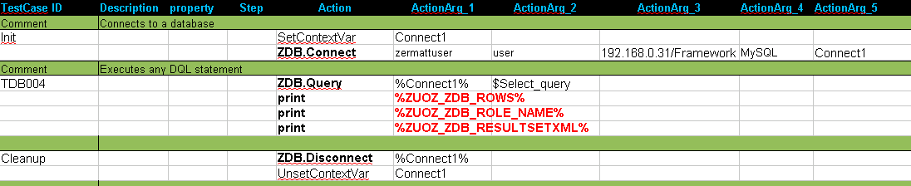

The output of the above %ZUOZ_RESULTSETXML% is as follows:
<Results>
<Row>
<role_name>test role</role_name>
<description>for testing</description>
</Row>
<Row>
<role_name>Zug Client</role_name>
<description>for testing</description>
</Row>
<Row>
<role_name>DB Client</role_name>
<description>for testing</description>
</Row>
</Results>

Exception:
Failure: AtomExecutionException message logged in log error file and the error message shown in console.

Parameter Name | Purpose | Type | Valid Values | Direction | Optional?
Connection_value | The handle of the database connection which was returned in a context variable, from a previous call to Connect. | Scalar | any string | Input | Required
Select_query | Any DQL query | Scalar | any string | Input | Required

10.5 WaitFor

Description

The atom allows the testcase to wait until a specific condition has been met or the timeout elapses. The atom will execute the SQL statement repeatedly, at 1 sec intervals ( the default, unless overridden by the testcase).
Note that the SQL statement is expected to return a value, which may be a string or an integer.

Zuoz Context-Variables for WaitFor atom
Zuoz defines and maintains an automatic global context variable for the WaitFor Atom. This variable may be used by the test case designer for developing test cases.

Name | Purpose | Comments | Default Value
ZUOZ_ZDB_ Retry_Interval_Seconds | States the timeout interval for the testcase to waitDefines the interval in seconds for the atom to wait between successive attempts | The value of this variable can be altered using SetContextVar | If the user does not change the value of this context variable, then the default interval is 1 sec.
Syntax:
ZDB.WaitFor(DBHandle, DBQuery, Value_For_Comparison, Condition_Operator, Timeout_In_Seconds)

Example:
ZDB.WaitFor(%Connect1%,$Execute_query,5,EQ,10)

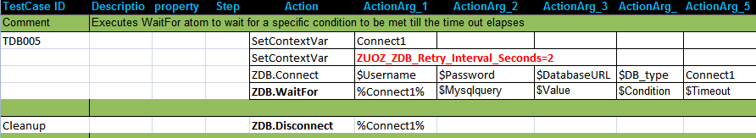

Exception:
Failure: AtomExecutionException message logged in log error file and the error message shown in console.

Parameter Name | Purpose | Type | Valid Values | Direction | Optional?
Connection_value | The handle of the database connection which was returned in a context variable, from a previous call to Connect. | Scalar | any string | Input | Required
Select_query | A SQL query, that returns a value to be compared | Scalar | any string | Input | Required
Value_for_Comparison | A value that can be used for comparison. It can be interpreted as numeric | Scalar | numeric | Input | Required
Condition_operator | A condition operator e.g ==, >, >=, !=, <, <= | Scalar | EQ, GT, GEQ, NEQ, LT, LEQ | Input | Required
timeout | Duration in seconds the atom will wait for the condition to be met. | Scalar | A string representing a integer value | Input | Required

10.6 Eval

Description

Zuoz can access any Database such as ORACLE, MSSQL, MYSQL using specified database credentials. This gives the user direct access to all the core functions of the database. This atom converts any function, supported by the underlying database, into a SQL statement, executes it, and returns the result into a context variable.

This atom is useful for doing string manipulations, and leveraging the built in functionality of databases.

Syntax:
ZDB.Eval(DBHandle, Function, Result)
Example:
ZDB.Eval(%Connect1%, $Formula, result)

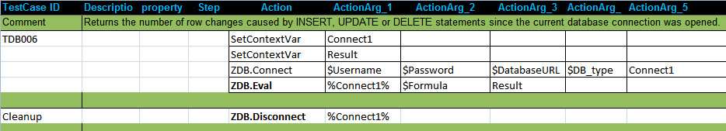

In the above example, the value of $Formula is total_changes(), which returns the number of row changes caused by INSERT, UPDATE or DELETE statements since the current database connection was opened. The result is stored in the context variable cv_result.

Exception:
Failure: AtomExecutionException message logged in log error file and the error message shown in console.

Parameter Name | Purpose | Type | Valid Values | Direction | Optional?
Connection_value | The handle of the database connection which was returned in a context variable, from a previous call to Connect. | Scalar | any string | Input | Required
Execute_formula | Any database core function | Scalar | Must be any of the valid for that given database | Input | Required
Result | The result of the execution is stored in this context variable. | Scalar | any string | Output | Required

FTP Atoms

All the Atoms in this section are available in ZFTP In process package file. These atoms are referenced in CHUR spreadsheet as ZFTP.<atom-name> because of the mapping done in ZugINI.xml. The following atoms can be used to connect as well as disconnect to a FTP server.

11.1 Connect

Description

Connects to a specific FTP server, validates user credentials, and returns a handle for the connection in a context variable. This handle can subsequently be used to download files, upload files and get the list of file names along with their details from a ftp server. Note that the connection is not thread-safe, i.e. not more than a single FTP operation can be concurrently executed using the same handle.

Example

Syntax:
ZFTP.Connect(Domain,Username,Password,FTPHandle)

Example:
ZFTP.Connect(192.168.0.2,JohnSmith, secret, FTPHandle)

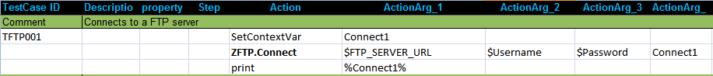

Exception:

Failure: AtomExecutionException message logged in log error file and the error message shown in console.

Parameter Name | Purpose | Type | Valid Values | Direction | Optional?
Domain | Domain name and port number of the FTP server | Scalar | An IP-V4 address, and optionally a port number, separated with a colon. | Input | Required
Username | Username of the FTP account | Scalar | any string, representing an authorized account | Input | Required
Password | Password of the FTP account | Scalar | any string, representing a valid password associated with the account | Input | Required
FTPHandle | Returns the connection in a context variable | Scalar | Any string representing the name of a context variable. | Output | Required

11.2 Disconnect

Description
Disconnects or destroys the connection with the FTP server.

Example
Syntax:
ZFTP.Disconnect(FTP_Handle)

Example:
ZFTP.Disconnect(%FTPHandle%)

Exception:

Failure: AtomExecutionException message logged in log error file and the error message shown in console.

Parameter Name | Purpose | Type | Valid Values | Direction | Optional?
FTP_Handle | The handle of the FTP connection which was returned in a context variable, from a previous call to Connect | Scalar | The string returned from a previous successful call to Connect | Input | Required

Example:

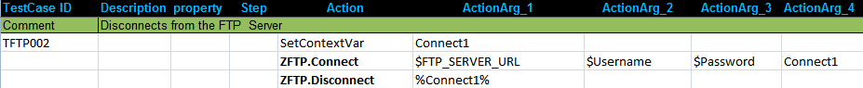

11.3 ChangeDir

Description

Changes from current directory to the desired path in the FTP server.

Example

Syntax:
ZFTP.ChangeDir(FTP_Handle,PathName)

Example:
ZDB.Execute(%Connect1%,$Path_name)

Here the macro $Path_name is assumed to be the name of the desired path in the FTP server. e.g.
$Path_name=/Users/Public/Documents

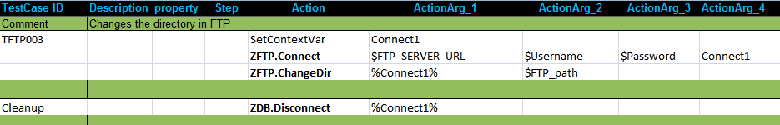

Exception:

Failure: AtomExecutionException message logged in log error file and the error message shown in console.

Parameter Name | Purpose | Type | Valid Values | Direction | Optional?
FTP_Handle | The handle of the FTP connection which was returned in a context variable, from a previous call to Connect | Scalar | The string returned from a previous successful call to Connect | Input | Required
Path_name | To go to specific path relative to the account's root directory in the FTP server. | Scalar | Specified path | Input | Required

11.4 Upload

Description

Uploads a file to the current working directory of the FTP server.

Example

Syntax:
ZFTP.Upload (FTP_Handle,Full_directory_of_the_File,File_name)

Example:
ZFTP.Upload(%Connect1%,C:\Users\Public\, Demo.xls)

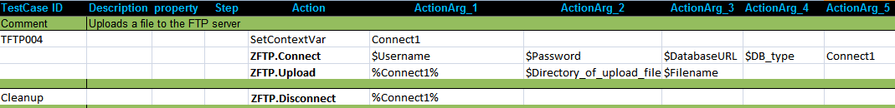

Exception:

Failure: AtomExecutionException message logged in log error file and the error message shown in console.

Parameter Name | Purpose | Type | Valid Values | Direction | Optional?
FTP_Handle | The handle of the FTP connection which was returned in a context variable, from a previous call to Connect | Scalar | The string returned from a previous successful call to Connect | Input | Required
Directory_of_the_the_file | The fully qualified path of file to be uploaded. | Scalar | any string( must end with \ ) | Input | Required
File_name | The file to be uploaded along with the extension. | Scalar | any string | Input | Required

11.5 Download

Description
Downloads a file from the current working directory of the FTP server to a given location.

Example

Syntax:
ZFTP.Download (FTP_Handle,File_name_to_be_downloaded, Destination_directory_of_the_File,)

Example:
ZFTP.Download(%Connect1%,Demo.xls,C:\Users\Public\Downloads)

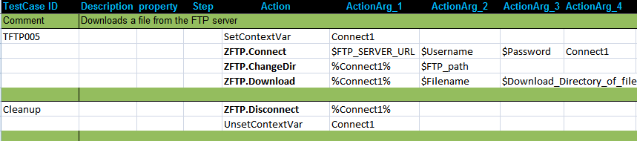

Exception:

Failure: AtomExecutionException message logged in log error file and the error message shown in console.

Parameter Name | Purpose | Type | Valid Values | Direction | Optional?
FTP_Handle | The handle of the FTP connection which was returned in a context variable, from a previous call to Connect. | Scalar | The string returned from a previous successful call to Connect | Input | Required
File_name | The file to be downloaded along with the extension. | Scalar | any string | Input | Required
Destination_directory_of_the_File | The fully qualified path where the file will be downloaded. | Scalar | any string( must end with \ ) | Input | Required

11.6 GetFileList

Description
Retrieves the list of files along with the detailed information of each file from the current directory in the FTP server to a context variable or to an XML file.

Example

Syntax:
ZFTP.GetFileList (FTP_Handle,mode,context_var OR file_name)

Example:
ZFTP.GetFileList(%Connect1%,CV, file_list)

The context variable file_list will contain all the list of files in XML format.

ZFTP.GetFileList(%Connect1%, FILE, $file_location )

The macro $file_location specifies the fully qualified path along with the XML file name where the list of files in the FTP server is retrieved.

$file_location=C:\Users\Public\Filelist.xml

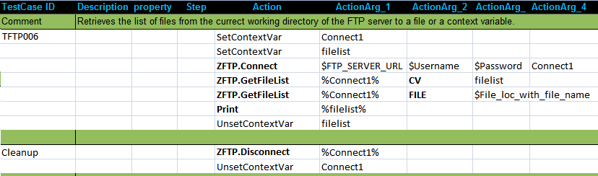

Exception:

Failure: AtomExecutionException message logged in log error file and the error message shown in console.
Parameter Name | Purpose | Type | Valid Values | Direction | Optional?
FTP_Handle | The handle of the FTP connection which was returned in a context variable, from a previous call to Connect | Scalar | The string returned from a previous successful call to Connect | Input | Required
mode | Specifies whether the output variables will be context variable or a file. | Scalar | FILE or CV | Input | Required
Contextvar  OR  File_name | Returns the XML content in that context variable  OR  Returns the XML content in an XML file. | Scalar | any string  OR  Fully qualified path along with filename | Input | Required

The following is an example of XML that might be returned to the Contextvar or to the File_name.

<?xml version="1.0"?>
-<root>-
<file>
<file-name>Demo.xls</file-name>
<file-type>xls</file-type>
<file-size>2781</file-size>
<user-name>1000</user-name>
<last-modified>Fri Jul 27 18:12:00 IST 2012</last-modified>
</file>
</root>

In the above xml, the file-size is in bytes. The user-name states the name of the user owning the file. This may be a string representation of the user number.

Mail Server atoms

All the Atoms in this section are available in ZPOP3 In process package file. These atoms are referenced in CHUR spreadsheet as ZPOP3.<atom-name> because of the mapping done in ZugINI.xml. The following atoms can connect as well disconnect from the Mail Server. Also the atoms can read a particular mail as well delete the same.

12.1 Connect

Description

Connects to a specific POP3 Mail server (with an optional port number), validates user credentials, and returns a handle for the connection in a context variable. This handle must subsequently be used for other email operations .

Example

Syntax:
ZPOP3.Connect(Contextvariablename, Hostname, Username,Password)

Example:
ZPOP3.Connect(Connect,pop.googlemail.com:995,ericviewer, eric6789)

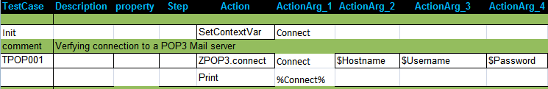

Exception:

Failure: AtomExecutionException message logged in log error file and the error message shown in console.

Parameter Name | Purpose | Type | Valid Values | Direction | Optional?
Contextvariablename | Name of a context variable where the handle will be returned | Scalar | Any string representing the name of a context variable. | Output | Required
Hostname | Server name along with the port number  ex-pop.googlemail.com:995 | Scalar | Any string representing the hostname, and the POP3 port. | Input | Required
Username | Username of the mail account | Scalar | any string | Input | Required
Password | Password of the mail account | Scalar | any string | Input | Required

12.2 Disconnect

Description
Disconnects or destroys the connection, represented by the handle, with the POP3 Mail server.

Example
Syntax:
ZPOP3.Disconnect(EmailHandle)

Example:
ZPOP3.Disconnect(%Connect%)

Exception:

Failure: AtomExecutionException message logged in log error file and the error message shown in console.

Parameter Name | Purpose | Type | Valid Values | Direction | Optional?
EmailHandle | The handle of the POP3 connection which was returned in a context variable, from a previous call to Connect. | Scalar | The string returned from a previous successful call to Connect | Input | Required

Example:

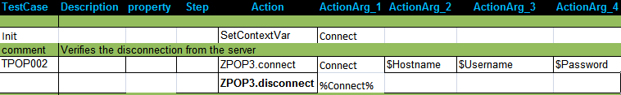

12.3 GetNewMsgCount

Description
Returns the count of mails or messages of the specified mail account in the mail server

Example
Syntax:
ZPOP3.GetNewMsgCount(EmailHandle, Email_Handle)

Example:
ZPOP3.GetNewMsgCount(%Connect%, No_of_messages_in_the_server)

Exception:

Failure: AtomExecutionException message logged in log error file and the error message shown in console.

Parameter Name | Purpose | Type | Valid Values | Direction | Optional?
EmailHandle | The handle of the POP3 connection which was returned in a context variable, from a previous call to Connect. | Scalar | The string returned from a previous successful call to Connect | Input | Required
Contextvariablename | To return a textual respresentation of a numeric value which states the no. of mails currently in the server | Scalar | any string, representing the name of a context variable | Output | Required

Example:

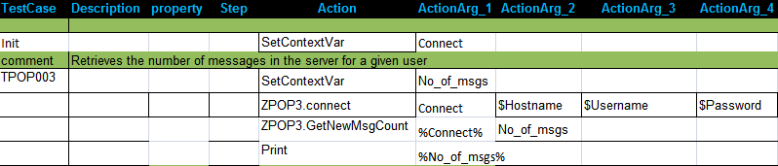

12.4 GetMessage

Description
Fetches all the attributes such as From, Subject, Date, MIME-Version and Message body of a mail for a given msg_index.

Zuoz Context-Variables for GetMessage atom

Zuoz defines and maintains automatic global context variables for the Execute Atom. These variables may be used by the test case designer for developing test cases.

Name | Purpose | Comments | Output
ZUOZ_POP3_From | Returns the name of the Sender of the mail | It returns the email address along with the name | A string.
ZUOZ_POP3_Subject | Returns the subject of the mail | If blank, it returns nothing . | A string.
ZUOZ_POP3_Date | Returns the Date when the mail was received |  | A string.
ZUOZ_POP3_MIME-Version | States the version of MIME |  | A string.
ZUOZ_POP3_MSG-BODY | Returns the body of the mail message | Contains the body of the mail

Exception:

Failure: AtomExecutionException message logged in log error file and the error message shown in console.

Example
Syntax:
ZPOP3.GetMessage(EmailHandle,Msg_index)

Example:
ZPOP3.GetMessage(%connect%,-1)

Parameter Name | Purpose | Type | Valid Values | Direction | Optional?
EmailHandle | The handle of the POP3 connection which was returned in a context variable, from a previous call to Connect. | Scalar | The string returned from a previous successful call to Connect | Input | Required
Msg_index | Specifies a particular message no. in the mail server | Scalar | 1: newest message  -1: oldest message  n: n^{th} newest message where n is any number. | Input | Required

Example:

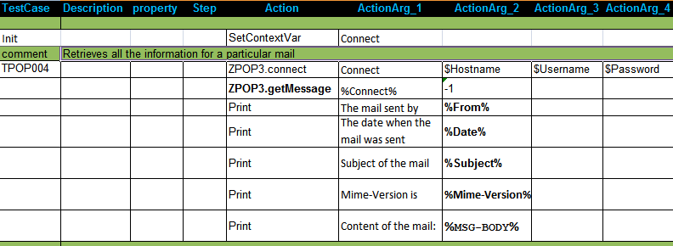

12.5 GetMessageFrom

Description
Fetches all the message attributes such as From, Subject, Date, MIME-Version and Message body of the mail for a given msg_index for a given Sender. In simple words, it fetches the n^{th} message of a particular sender or a particular date or a particular subject.

Zuoz Context-Variables for GetMessageFrom atom
The context variables for GetMessageFrom atom are the same as listed under GetMessage atom.

Example
Syntax:
ZPOP3.GetMessageFrom(EmailHandle,Msg_index, Field_name,Field_value)

Example:
ZPOP3.GetMessage(%connect%,1, Subject, test mail)

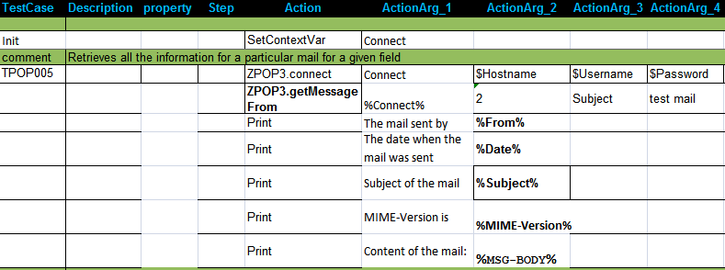

Exception:

Failure: AtomExecutionException message logged in log error file and the error message shown in console.

Parameter Name | Purpose | Type | Valid Values | Direction | Optional?
EmailHandle | The handle of the POP3 connection which was returned in a context variable, from a previous call to Connect. | Scalar | The string returned from a previous successful call to Connect | Input | Required
Msg_index | Specifies a particular message from a sender no. in the mail server | Scalar | 1: newest message  -1: oldest message  n: n^{th} newest message where n is any number. | Input | Required
Field_name | The particular field of the mail | Scalar | Subject or Date or From | Input | Required
Field_value | The value of the above field | Scalar | Any string | Input | Required

Example:

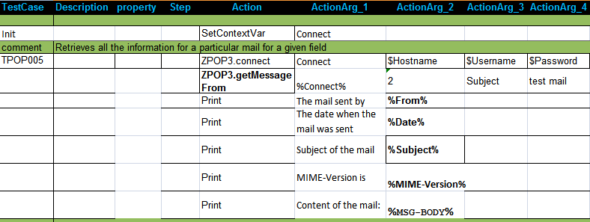

12.6 DeleteMsg

Description
Deletes a particular mail for a given msg_index from the Mail Server.

Example
Syntax:
ZPOP3.DeleteMsg(EmailHandle,Msg_index)

Example:
ZPOP3.DeleteMsg(%connect%,3)

Exception:

Failure: AtomExecutionException message logged in log error file and the error message shown in console.

Parameter Name | Purpose | Type | Valid Values | Direction | Optional?
EmailHandle | The handle of the POP3 connection which was returned in a context variable, from a previous call to Connect. | Scalar | The string returned from a previous successful call to Connect | Input | Required
Msg_index | Specifies a particular message no. in the mail server | Scalar | 1: newest message  -1: oldest message  n: n^{th} newest message where n is any number. | Input | Required

Example:

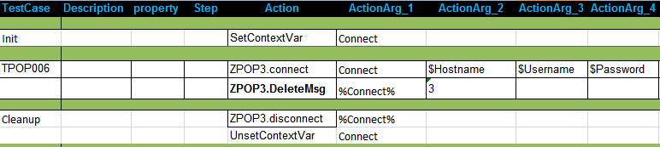

12.7 DeleteLastMsg

Description
Deletes the last message that was read from the POP3 Mail server.

Example
Syntax:
ZPOP3.DeleteLastMsg(EmailHandle)

Example:
ZPOP3.DeleteLastMsg(%Connect%)

Exception:

Failure: AtomExecutionException message logged in log error file and the error message shown in console.
Parameter Name | Purpose | Type | Valid Values | Direction | Optional?
EmailHandle | The handle of the POP3 connection which was returned in a context variable, from a previous call to Connect. | Scalar | The string returned from a previous successful call to Connect | Input | Required

Example:

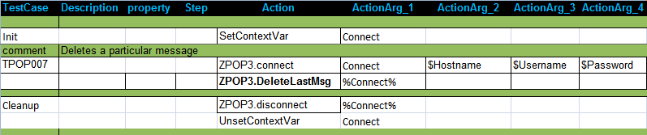

12.8 PurgeAllMsgs

Description
Deletes all the message matching the particular key-value pair from the POP3 Mail server.

Zuoz Environment Variable for PurgeAllMsg atom
The environment variable for PurgeAllMsgs atom is Deleted-Msg-Count. It states the number of messages deleted from the server.

Example
Syntax:
ZPOP3.PurgeAllMsgs(EmailHandle,MatchOptions)

Example:
ZPOP3.PurgeAllMsgs(%Connect%, from=Eric Viewer)

Exception:

Failure: AtomExecutionException message logged in log error file and the error message shown in console.

Parameter Name | Purpose | Type | Valid Values | Direction | Optional?
EmailHandle | The handle of the POP3 connection which was returned in a context variable, from a previous call to Connect. | Scalar | The string returned from a previous successful call to Connect | Input | Required
MatchOptions | A key value pair specifying the value of a specific field of the mail. | Scalar | Field_name=Field_values | Input | Required

Example:

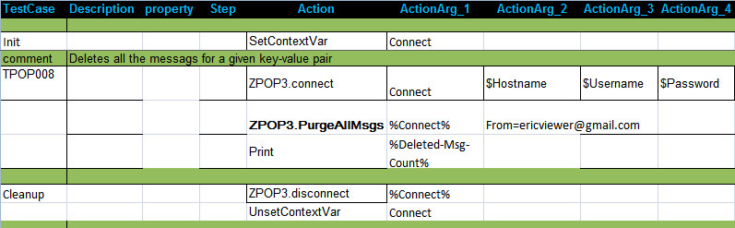

To know the Process Environment Variables, type set in the command prompt.
To know the Process Environment Variables, type set in the command prompt.

